### Team Name

* + Biryani

### Project Name

* + Film Finder

### Project Description

* + This application will allow users to find movies given criteria. By using a NoSQL deployment, we can scale horizontally to allow more data storage. Additionally, it is easier to query data because the database is schemaless. This project has a console application written in python using pymongo driver that connects to the sharded mongodb cluster and performs the functions by interacting with the database.

### Project Successes - List and describe the highlights and key success factors of the project

* + Successfully set up a sharded cluster in AWS as a EC2 instance.
  + Imported all data from a public dataset of movie information.
  + Wrangled data successfully by splitting data.
  + Connected to the database with PyMongo and issue queries from there.
  + Built 18 functionalities and allowed users to access them through console commands.

### Unexpected Events - List and describe any unexpected events that occurred during the project and the impact that those events may have had on the project and the action(s) taken to address them.

* + Unexpected event: While trying to import the big dataset, one of the shards kept shutting down.
  + Actions are taken: We changed the instance size from micro to large instance with 2 CPUs. We split the big data using python code. Then we imported each split data file into MongoDB.

### Lessons Learned - List and describe any lessons learned from this project and provide recommendations that can be used to improve the delivery of future information systems projects.

* + Instances must be sufficient for large datasets.
  + It is useful to use EC2’s “monitor” tab to find more information about the state of an instance.

### DataSet

* + URL of the data set: <https://grouplens.org/datasets/movielens/latest/>
  + One line of description of the data set: The data set has collections of movies, ratings, and tags related to movies.
  + Data set’s size: 1.32 GB
  + 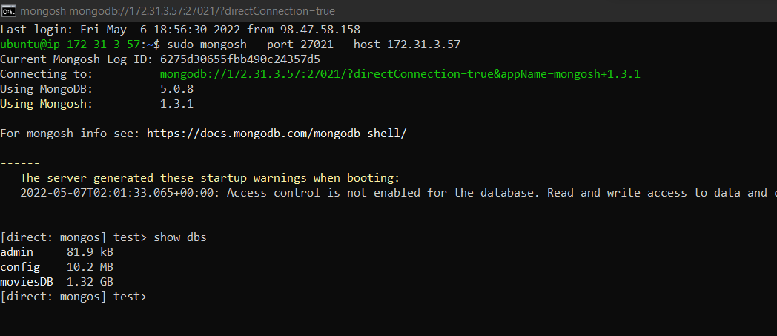
  + A detailed description of the data wrangling method: The movies.csv had the genres column that had the genres as a String separated by “|”. We had to wrangle the data to make this column, an array of strings. We imported the data as it is to the cluster and using the query made changes to the documents.
  + Data before wrangling:
  + 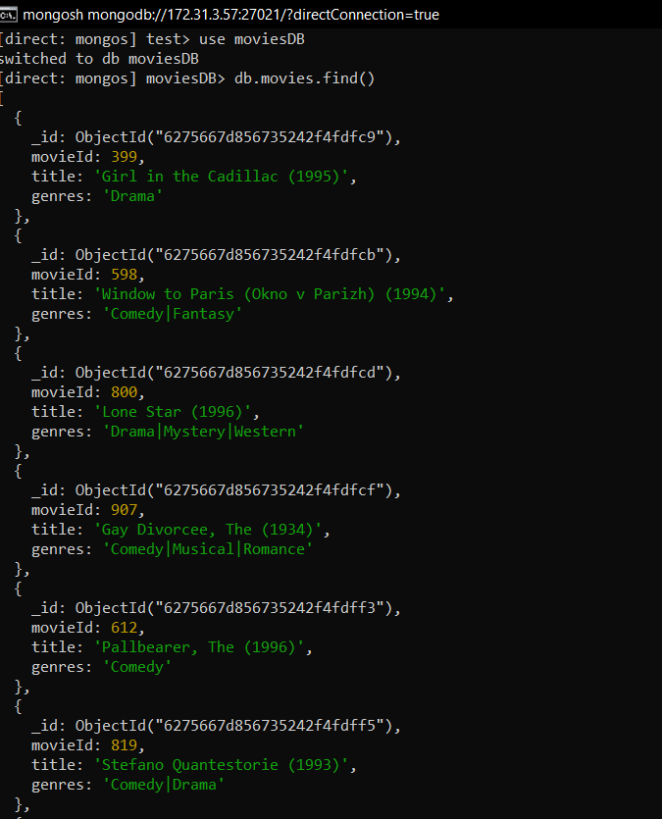

Function for wrangling:

db.movies.find().forEach(function (el)

{ el.genres = el.genres.split('|');

db.movies.update({ movieId :el.movieId},

{$set : {genres : el.genres }}); });



Data after wrangling:

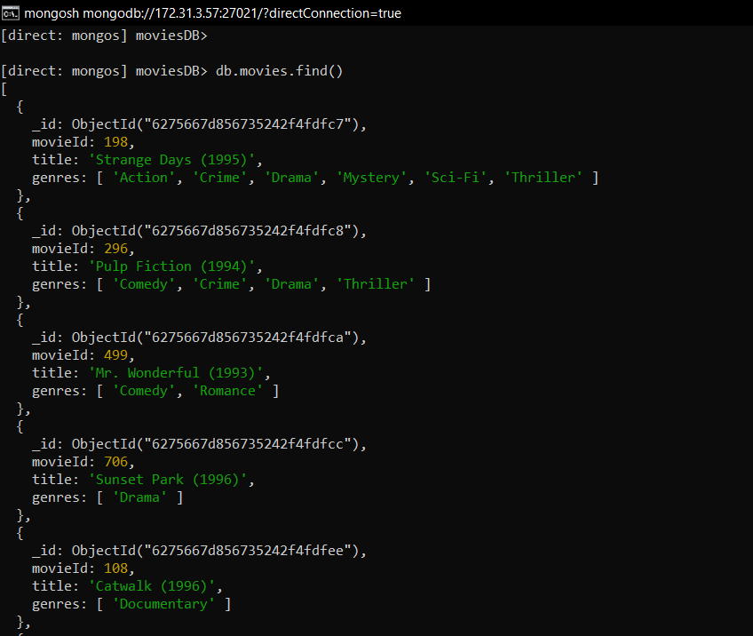

### Database Schema description, including what collections and indexes are created.

* + Movie (lists of movies) indexed on movieId:
    - movieId: number
    - title: String
    - genres: String[]
  + Tags (user created tags describing a movie) indexed on userId:
    - userId: number
    - movieId: number
    - tag: String
    - timestamp: timestamp
  + Ratings (rating given by a user for a movie) indexed on userId:
    - userId: number
    - movieId: number
    - rating: number
    - timestamp: timestamp

### NoSQL configuration including virtual machines, replica set, and sharding configuration. Explain these briefly but clearly and also include essential screenshots.

* + 5 total instances:
    - 1 instance to host all three config servers
    - 1 instance to host mongos for whole cluster
    - 3 instance for each of the 3 shards where each shard instance will host its 3 members in replica set

| Service | Daemon | Port(s) | Db Path | Public Ip | Private Ip |
| --- | --- | --- | --- | --- | --- |
| Shard Controller | mongos | 27021 | N/A | 44.199.241.48 | 172.31.3.57 |
| Config Server | mongod | 27022 | /db/config/data | 3.238.184.65 | 172.31.10.29 |
| Replica Set a (for shard a) | mongod | 26000, 26001, 26002 | a0, a1, a2 | 44.193.219.201 | 172.31.11.102 |
| Replica Set b (for shard b) | mongod | 26100, 261001, 261002 | b0, b1, b2 | 44.202.190.48 | 172.31.15.80 |
| Replica Set c (for shard c) | mongod | 26200, 26201, 26202 | c0, c1, c2 | 34.237.144.31 | 172.31.5.43 |

Config Server

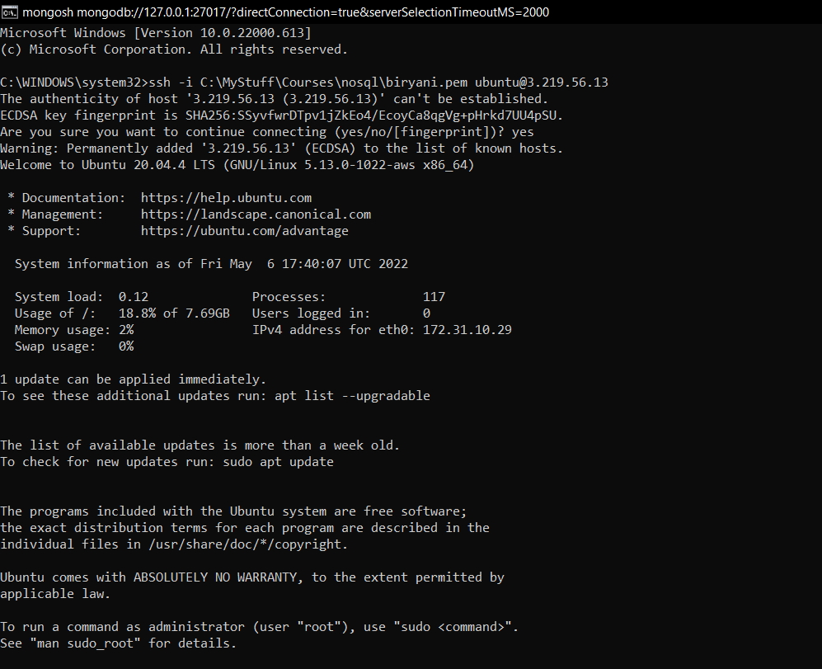

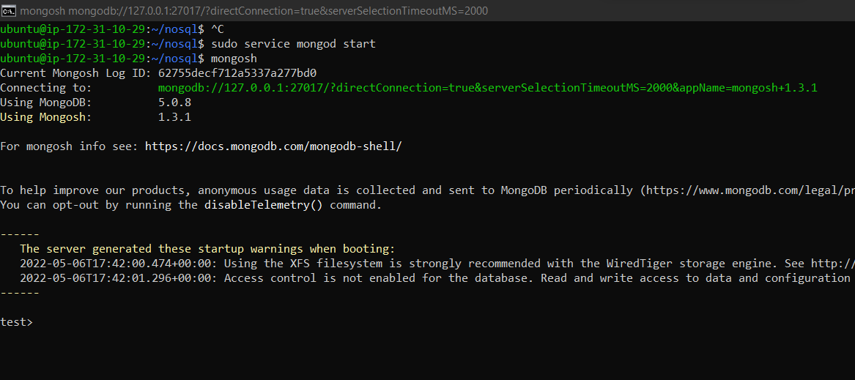

Mongos server

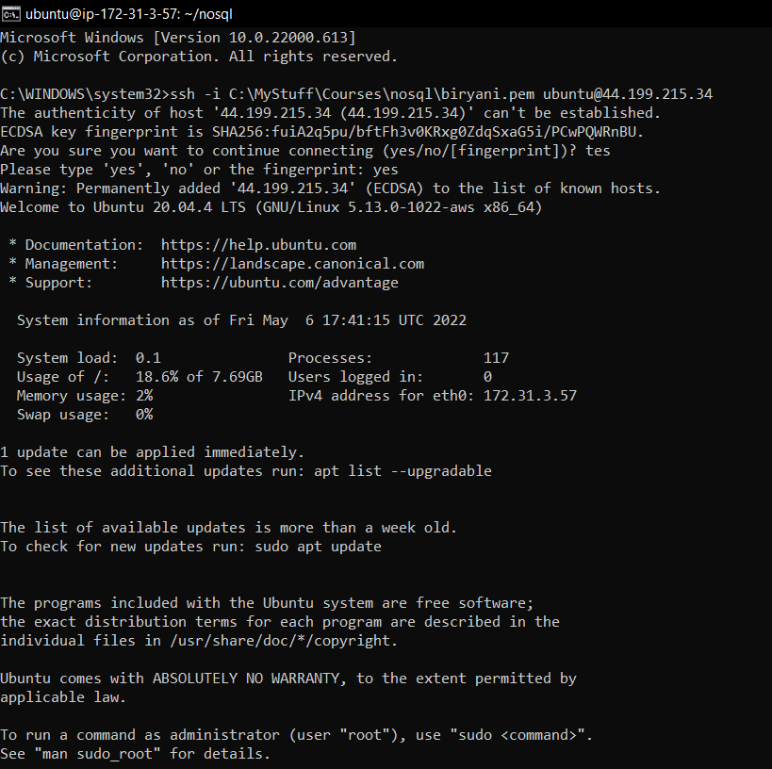

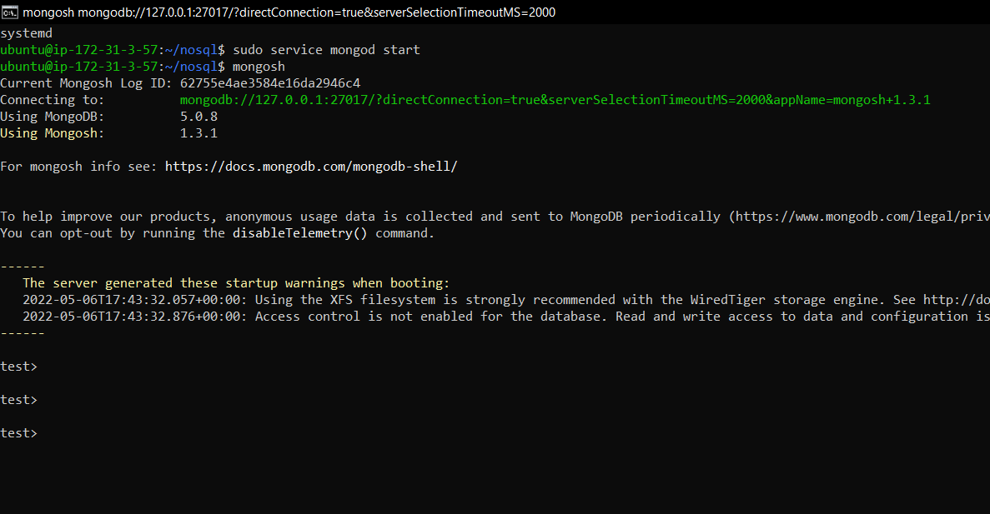

RS0

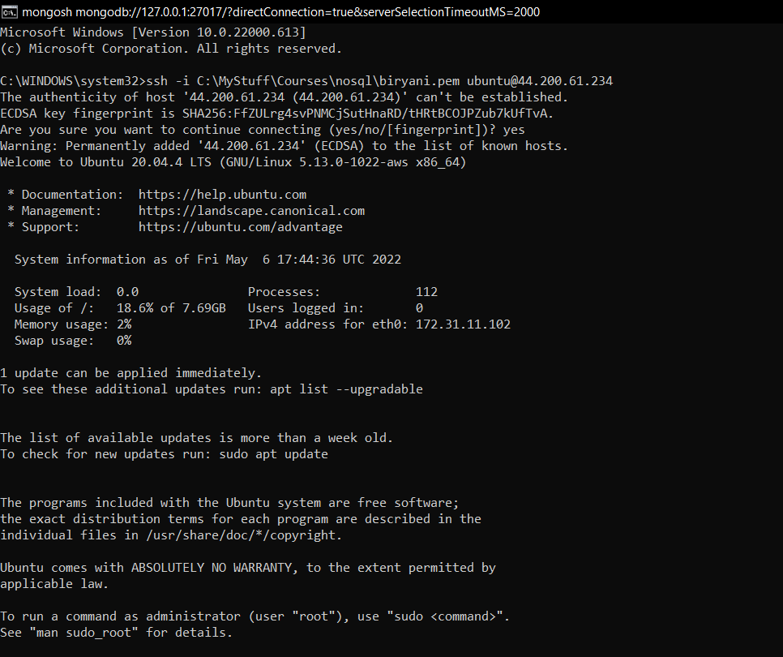

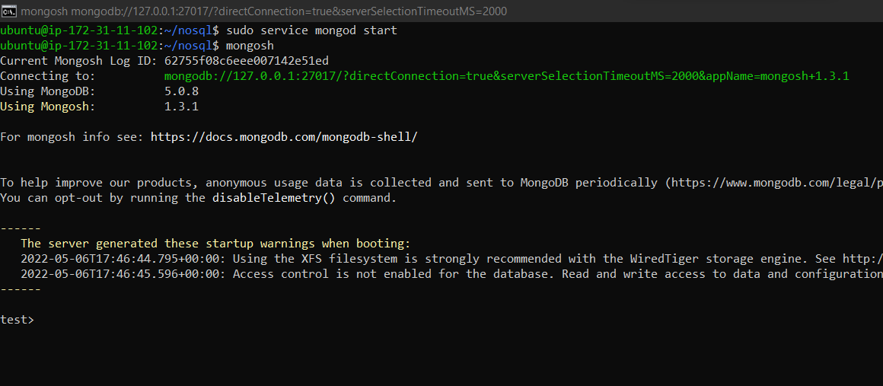

RS1

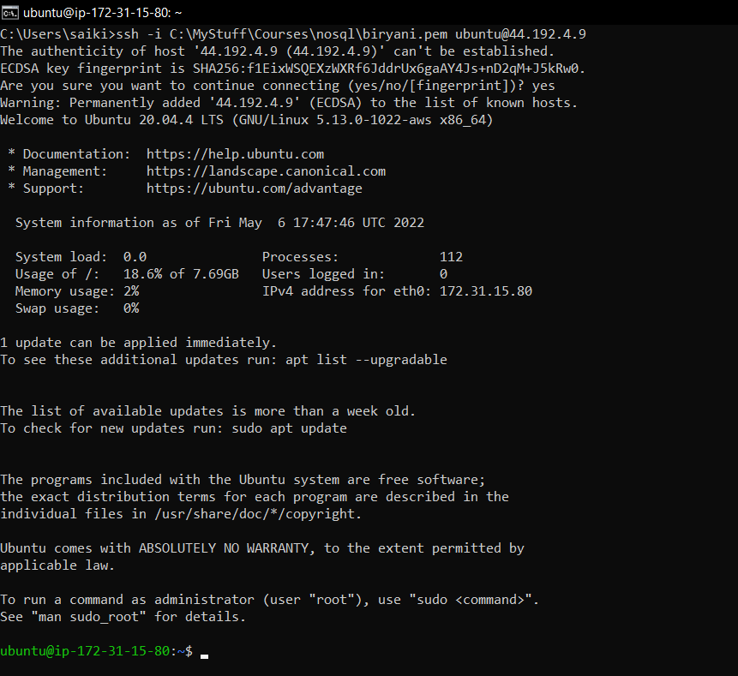

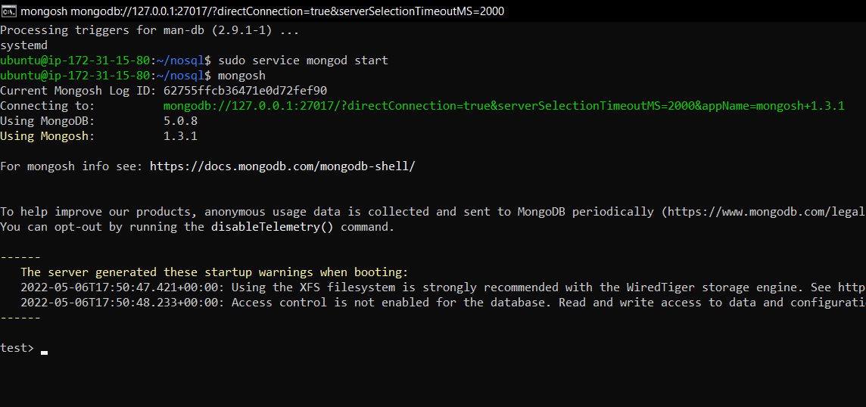

RS2

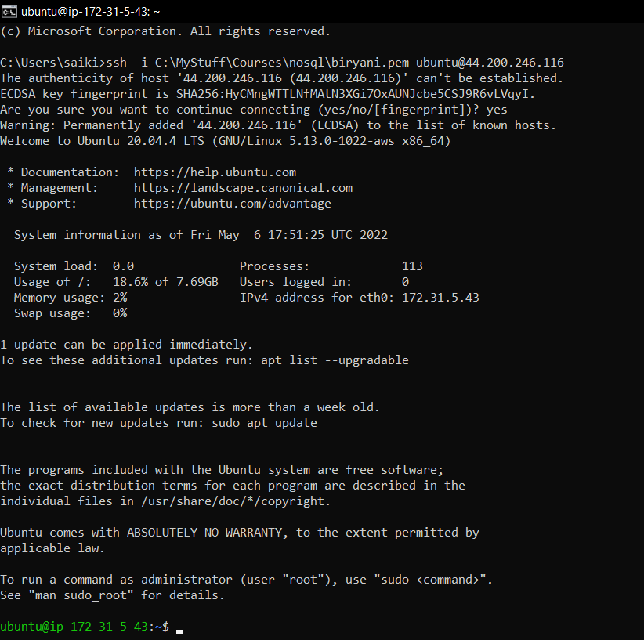

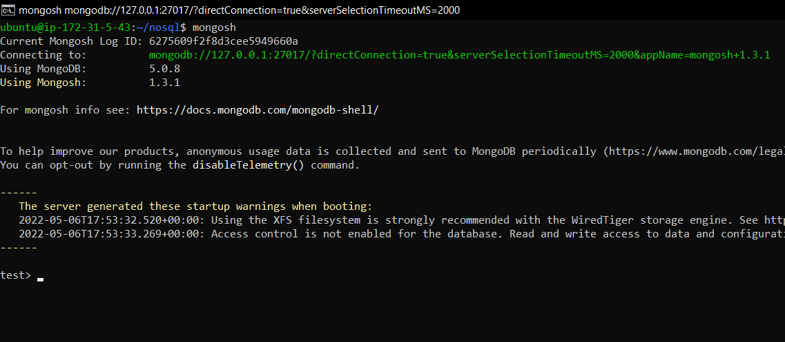

Config server configuration

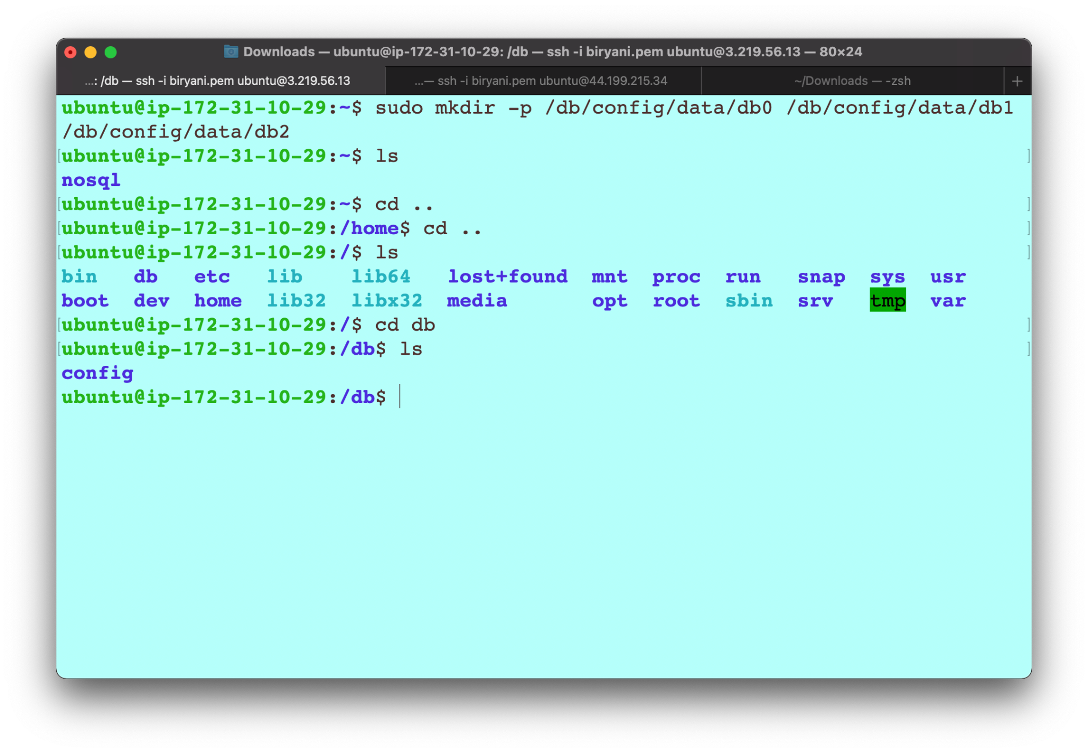

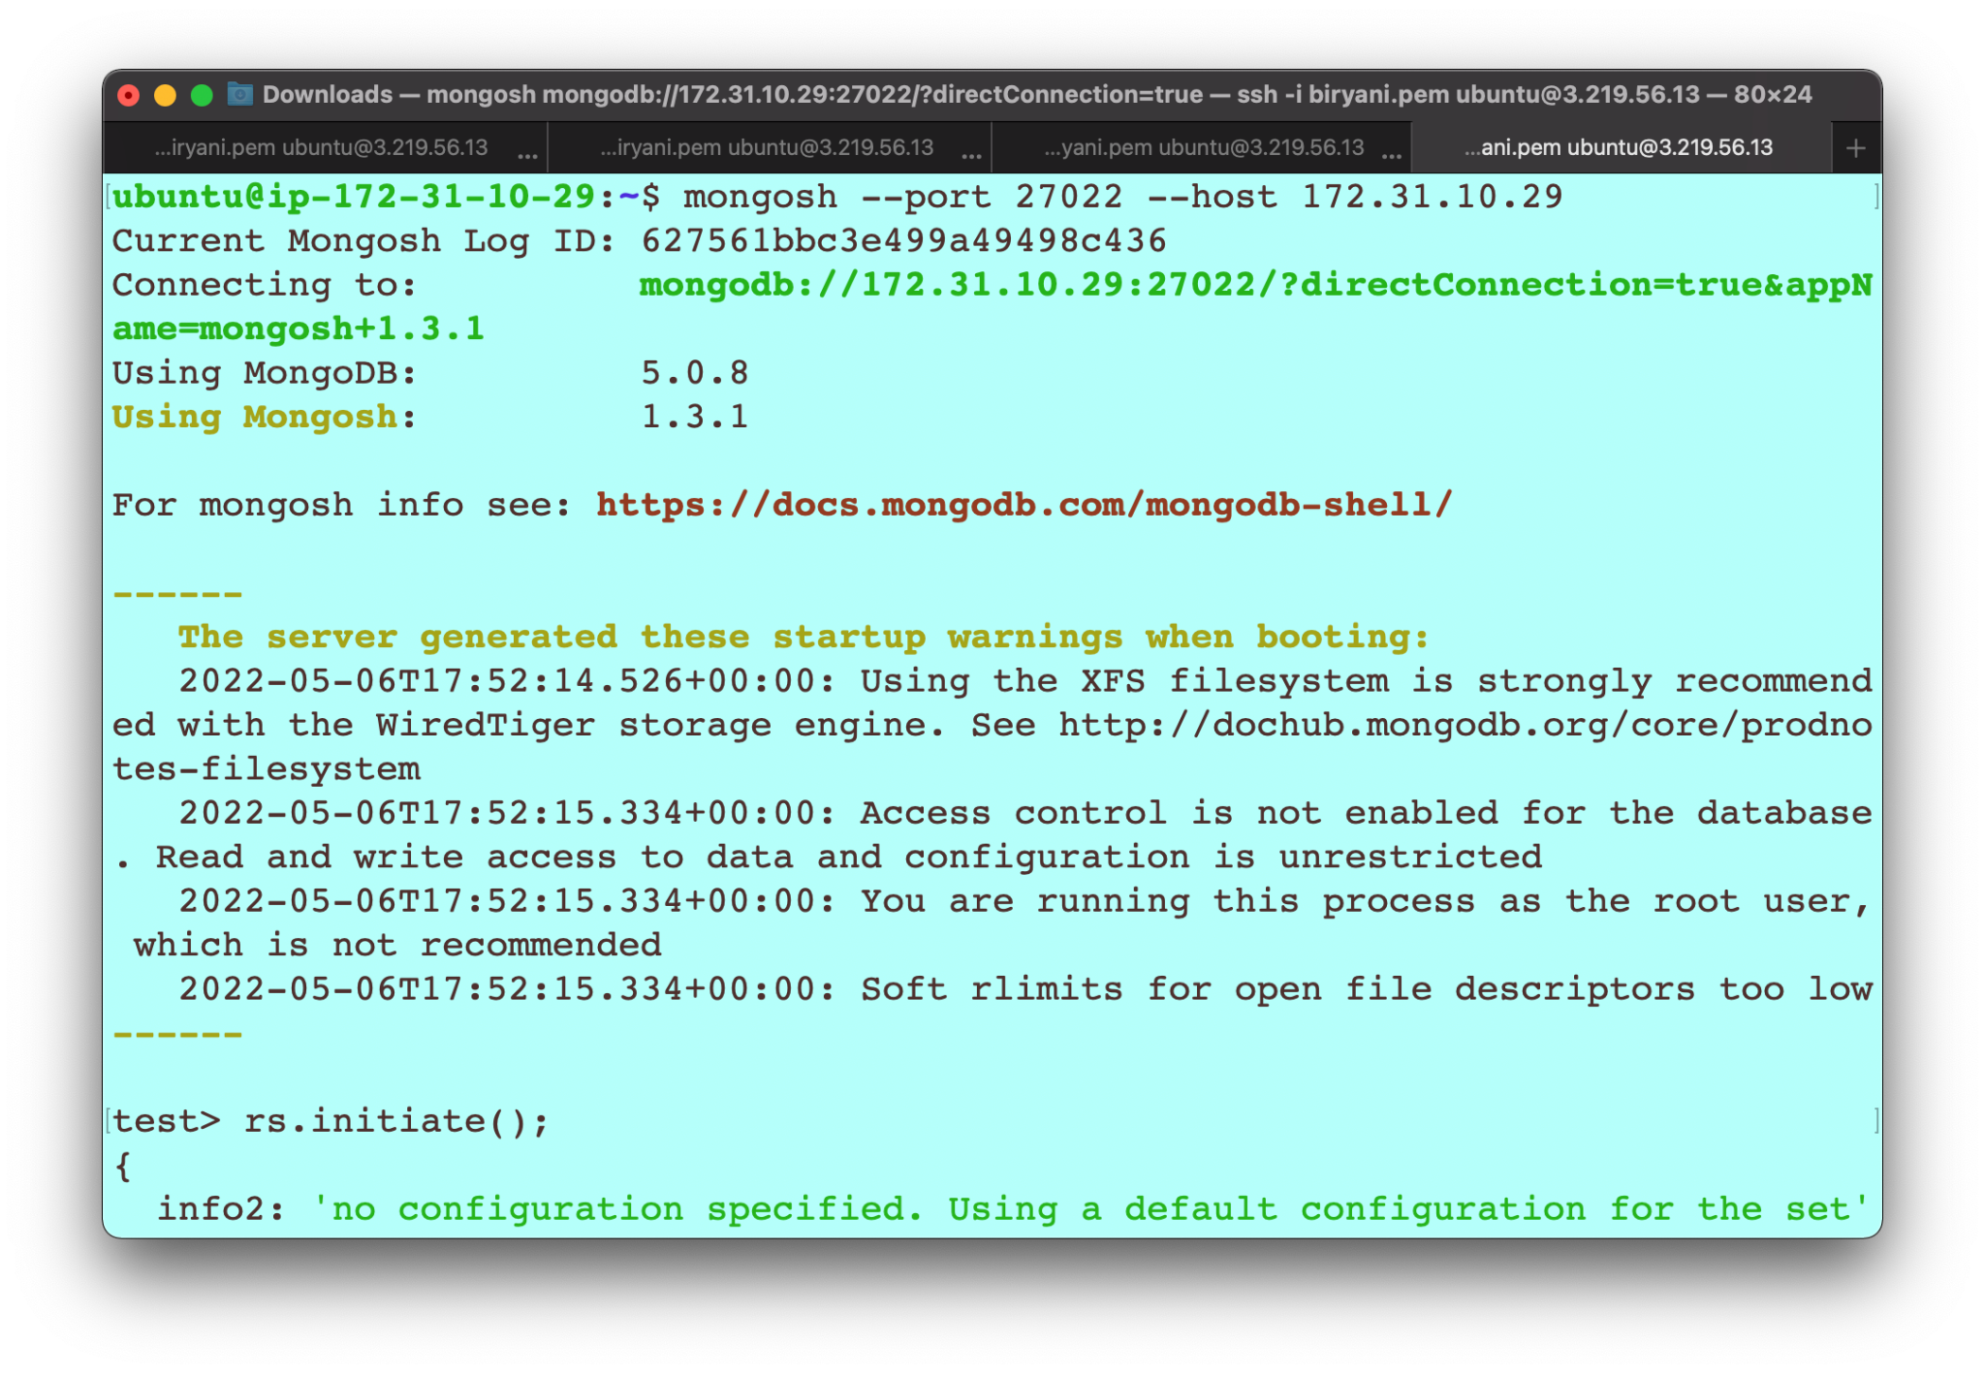

Config server replica set

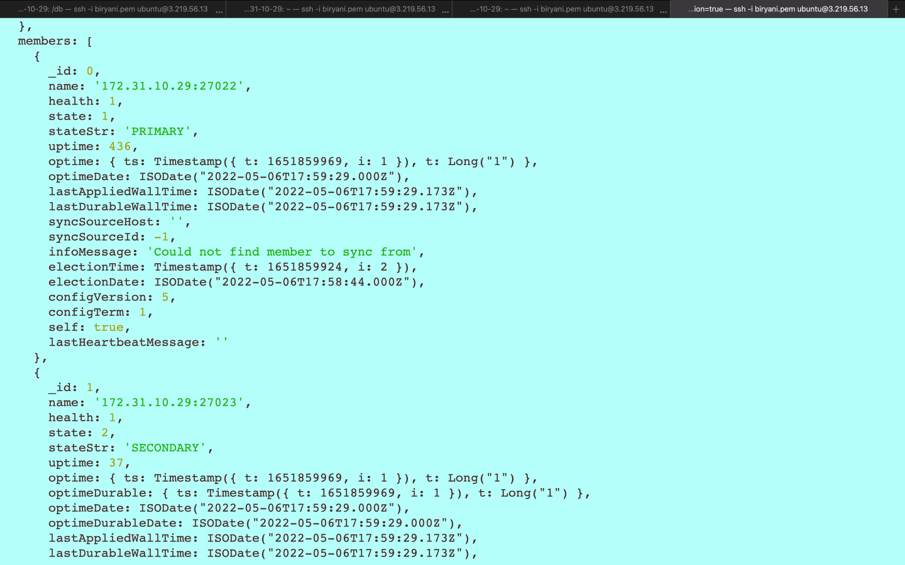

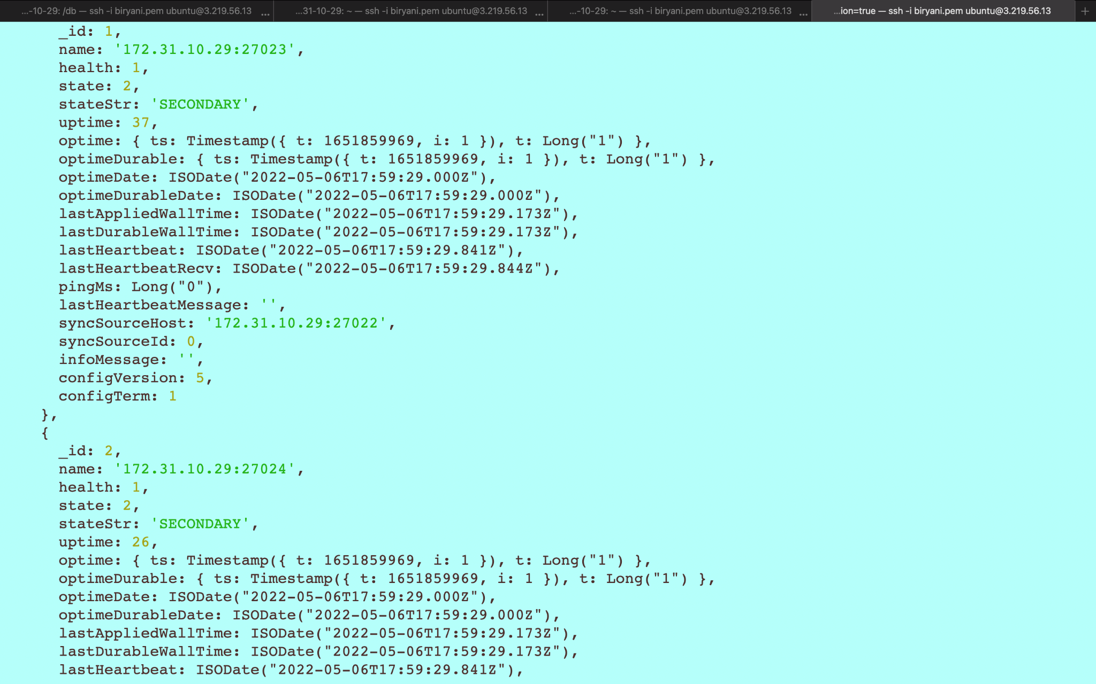

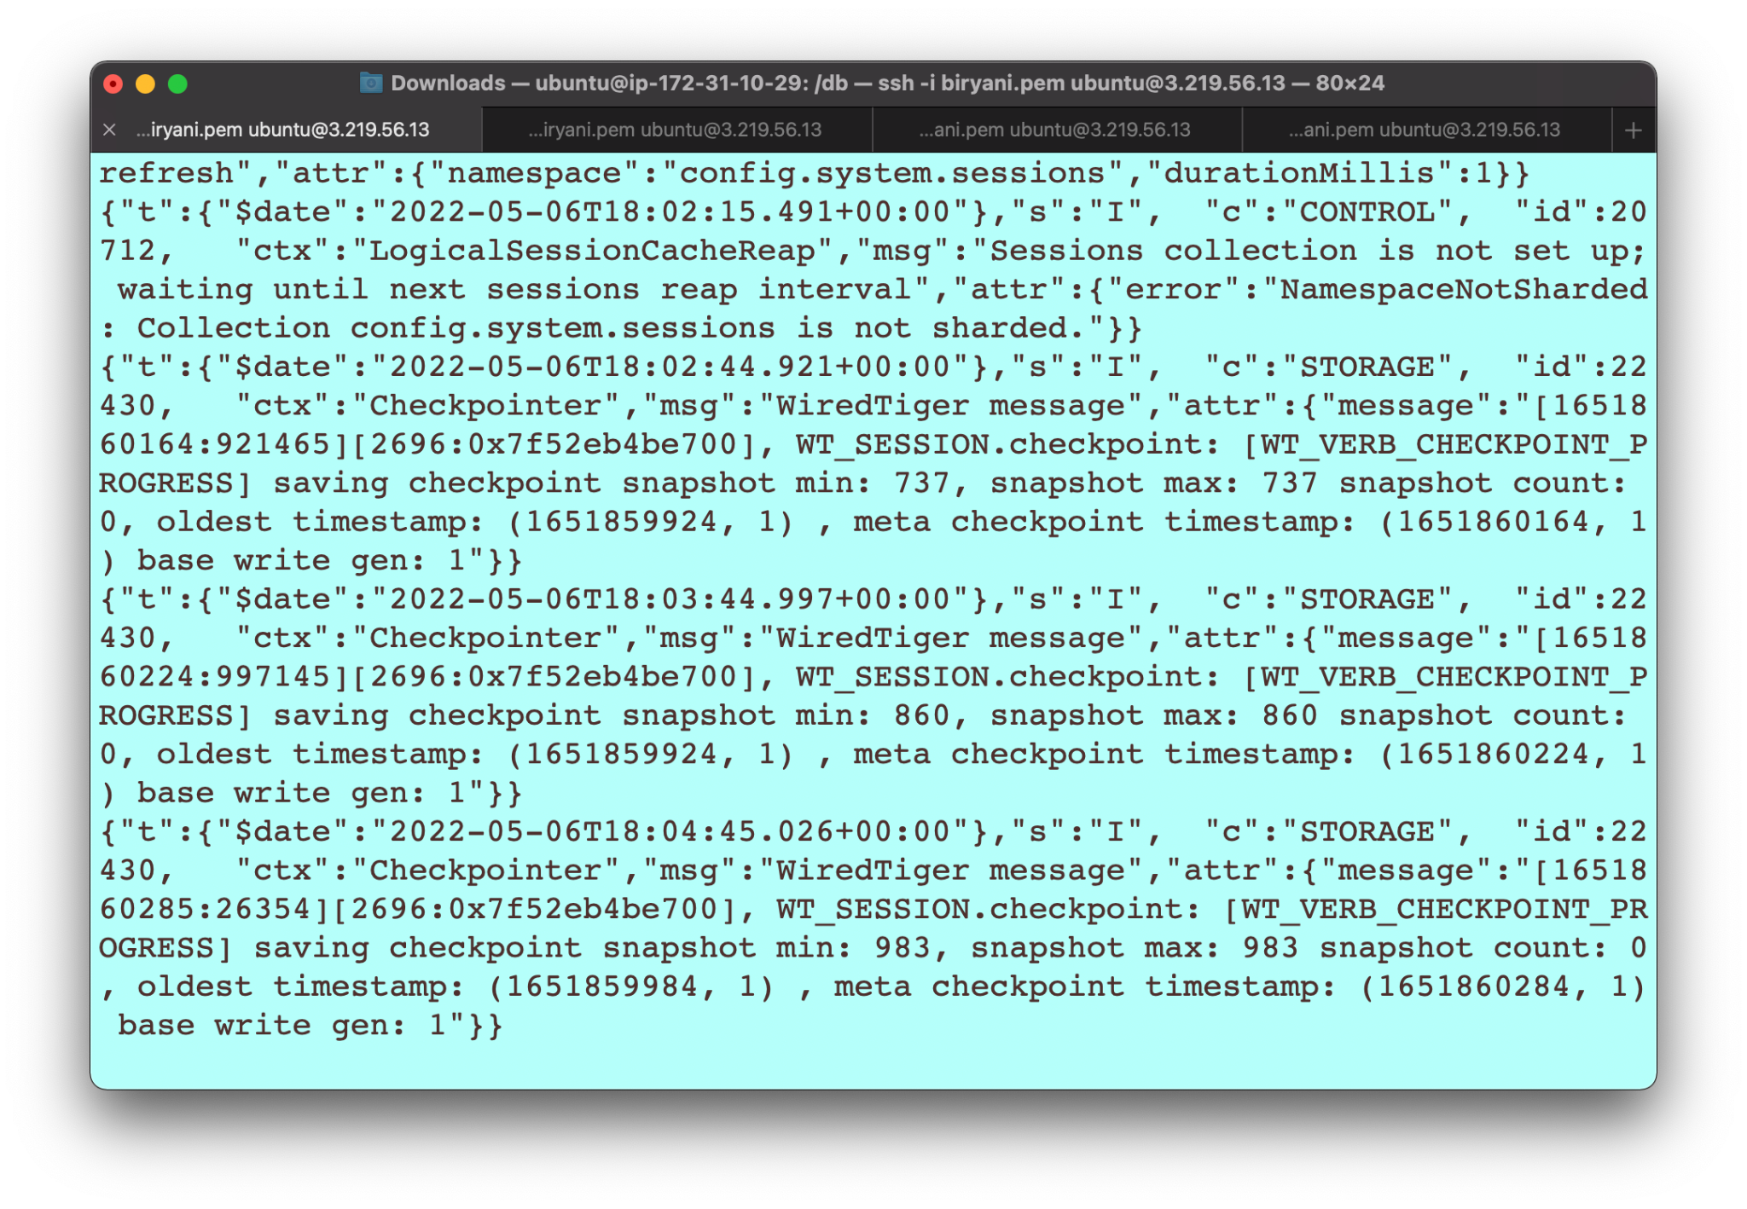

RS0 replicating

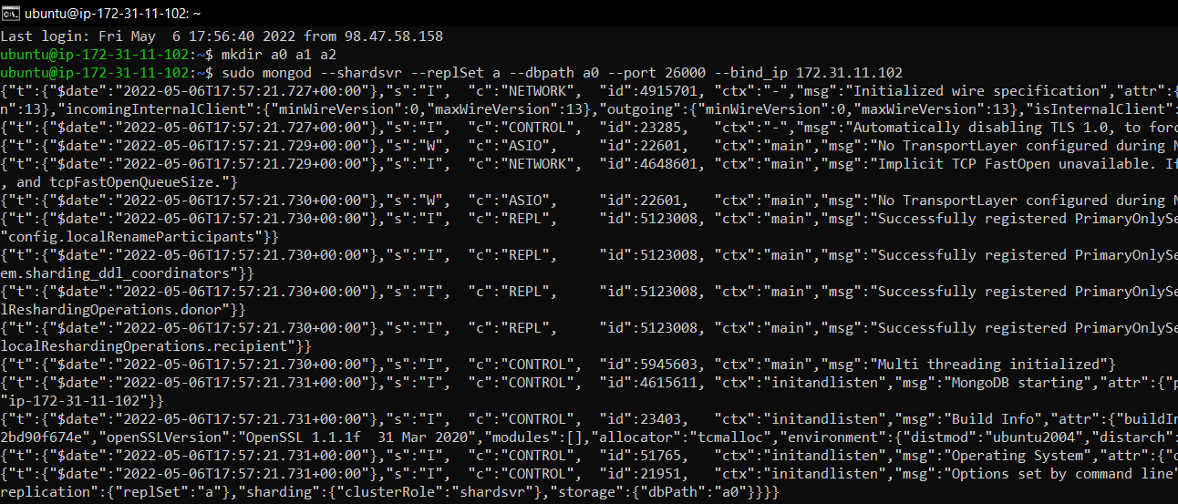

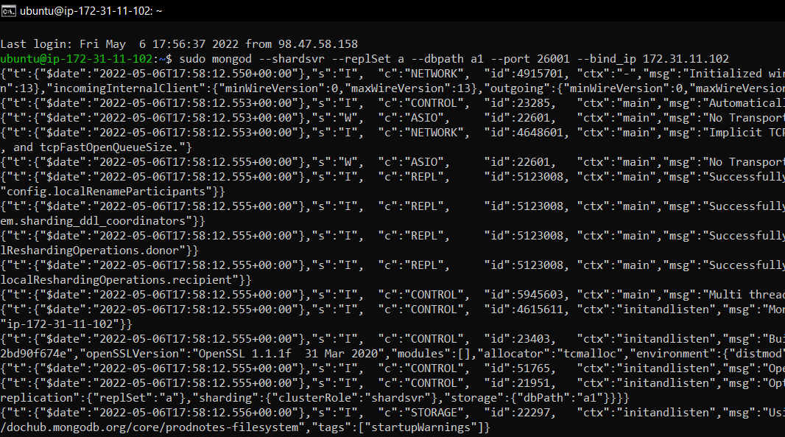

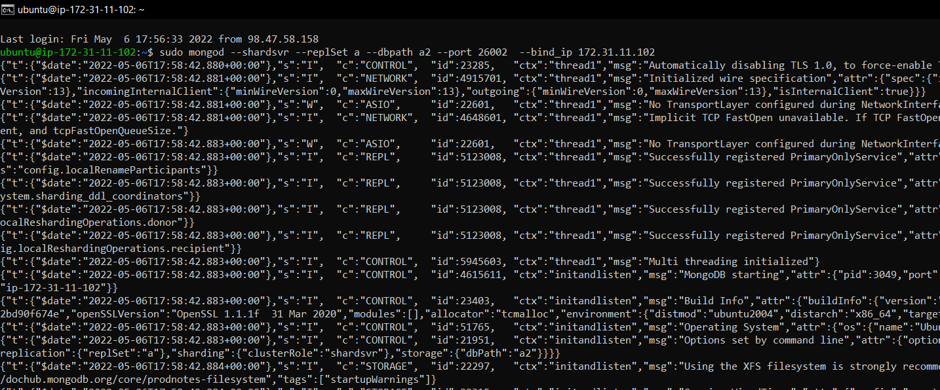

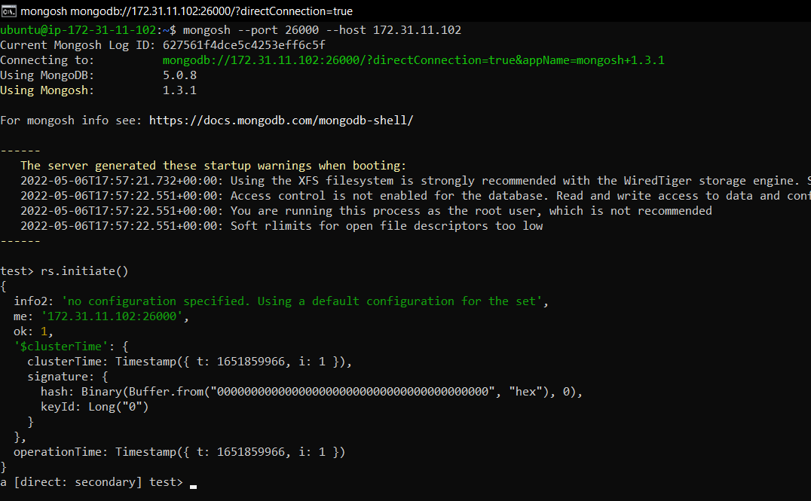

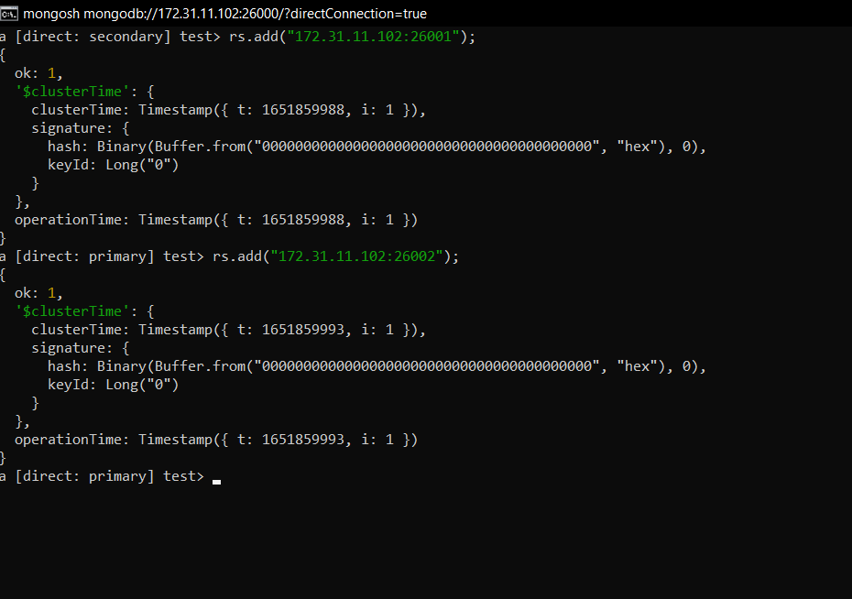

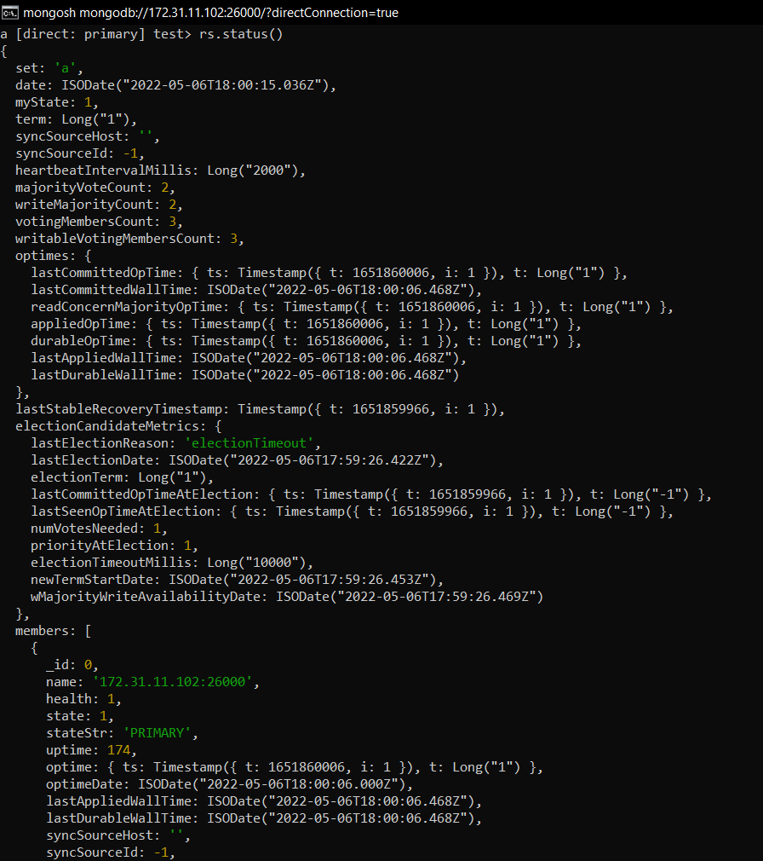

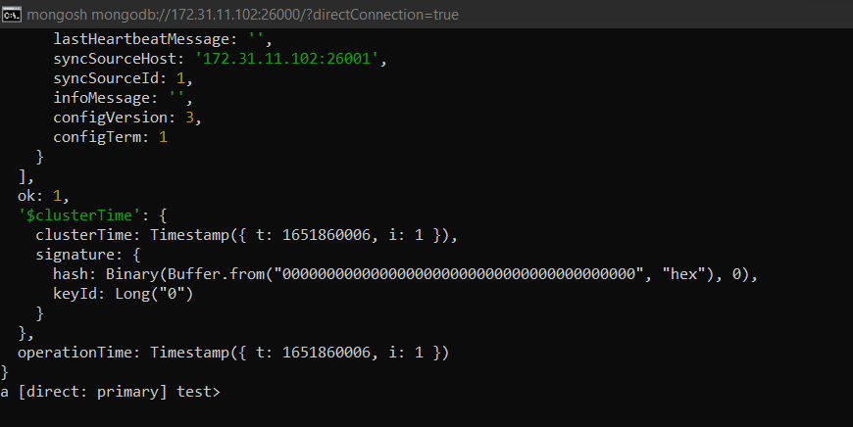

RS1 Replicating

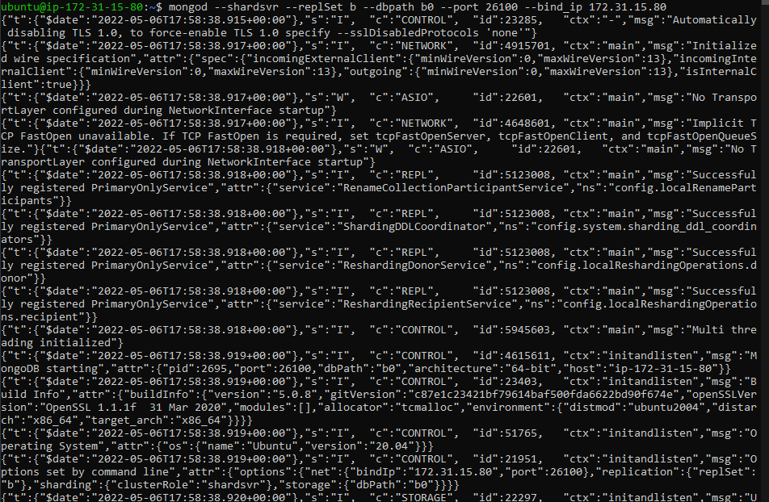

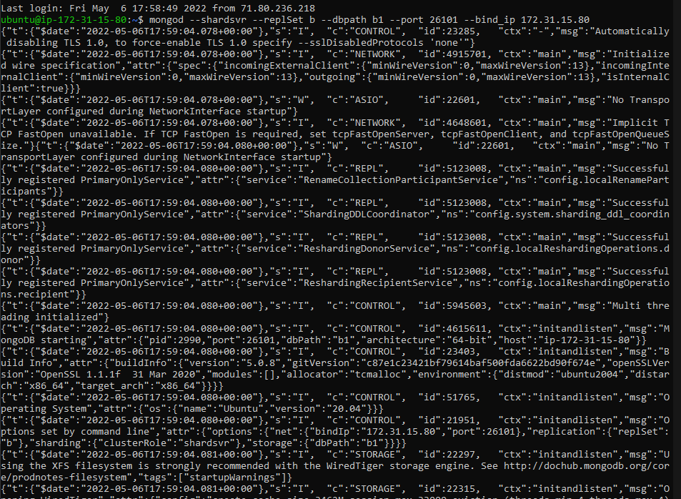

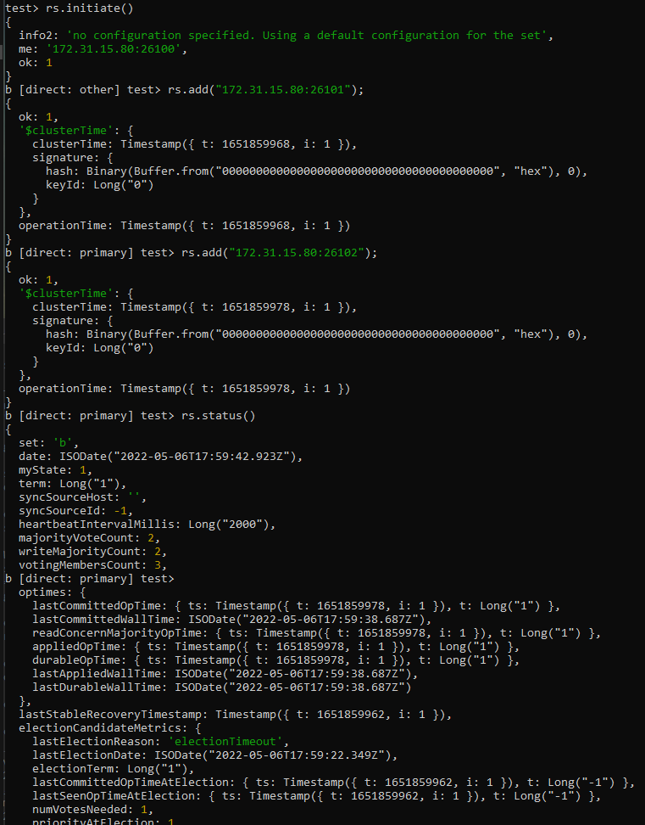

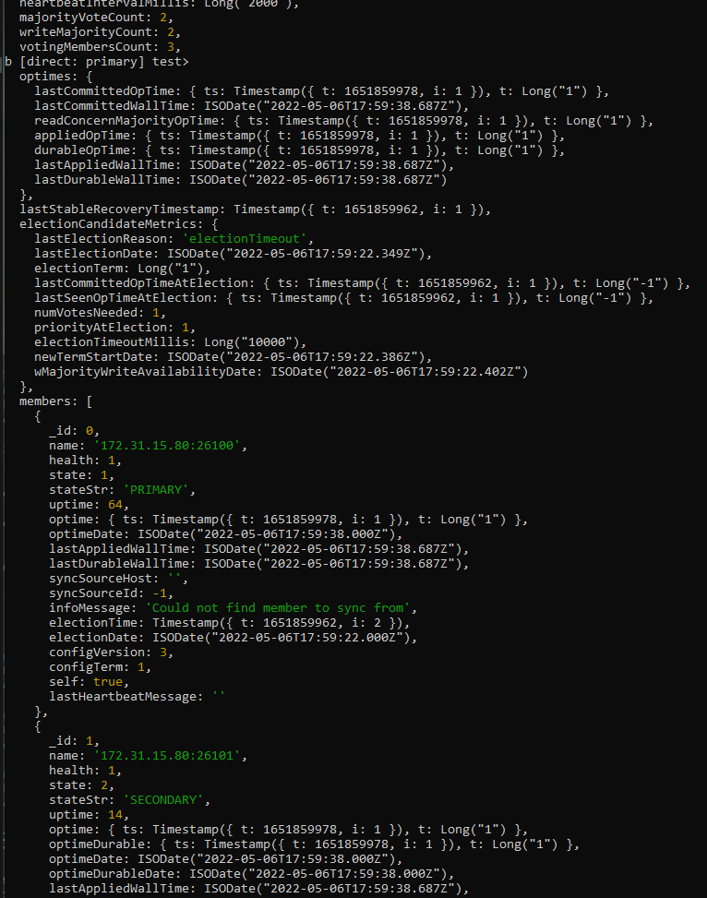

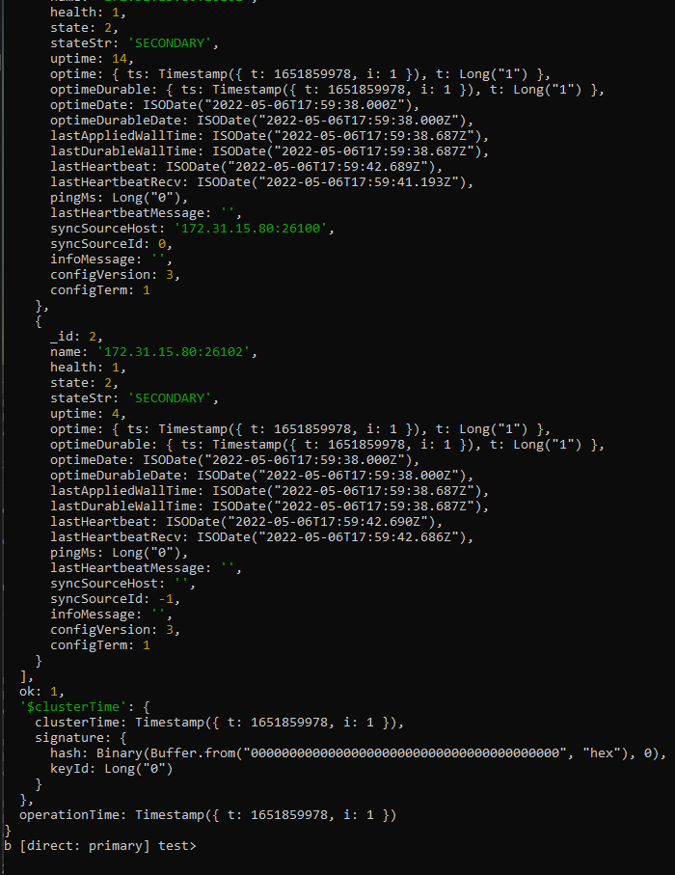

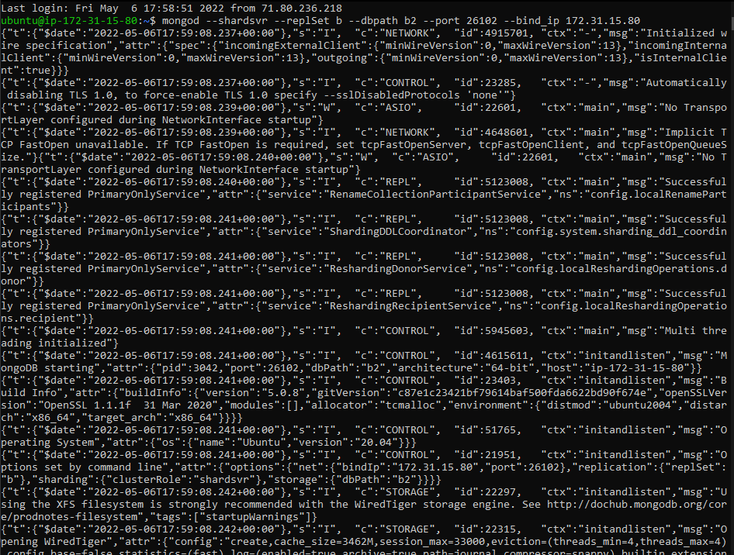

RS2 replicating

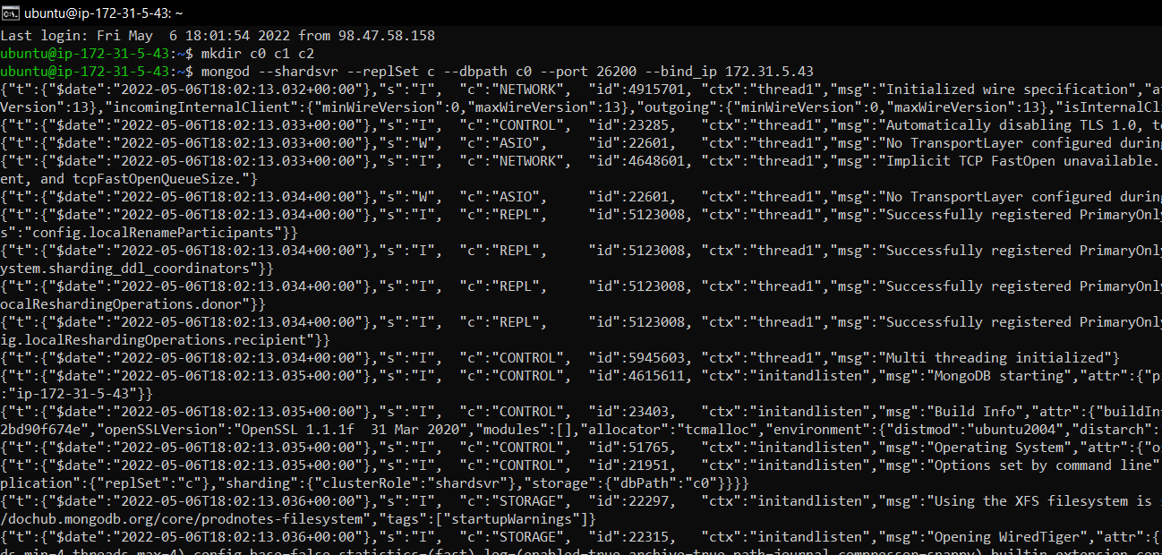

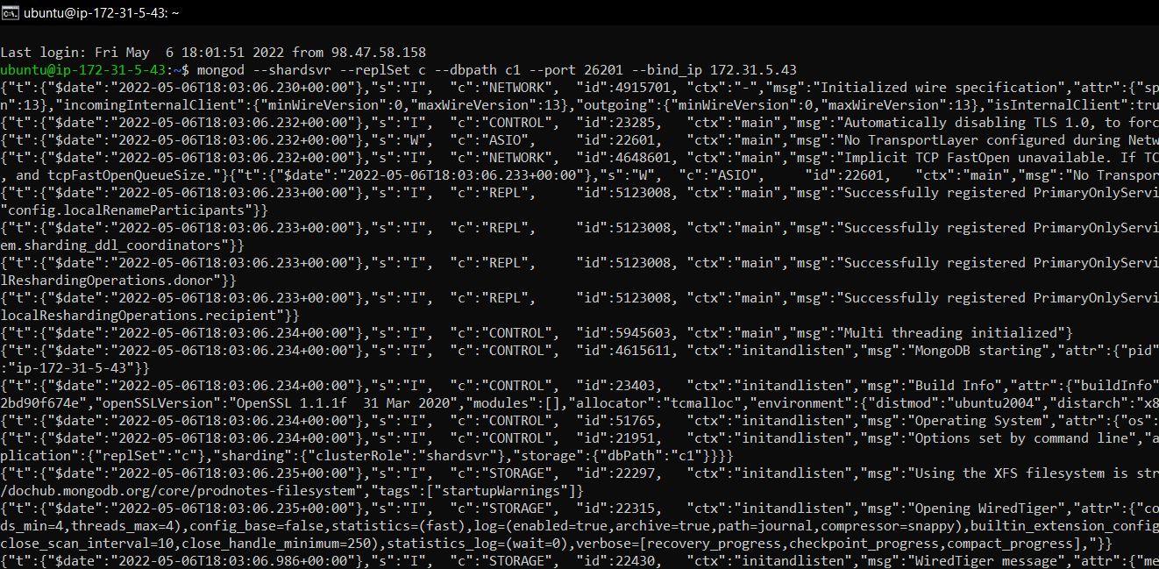

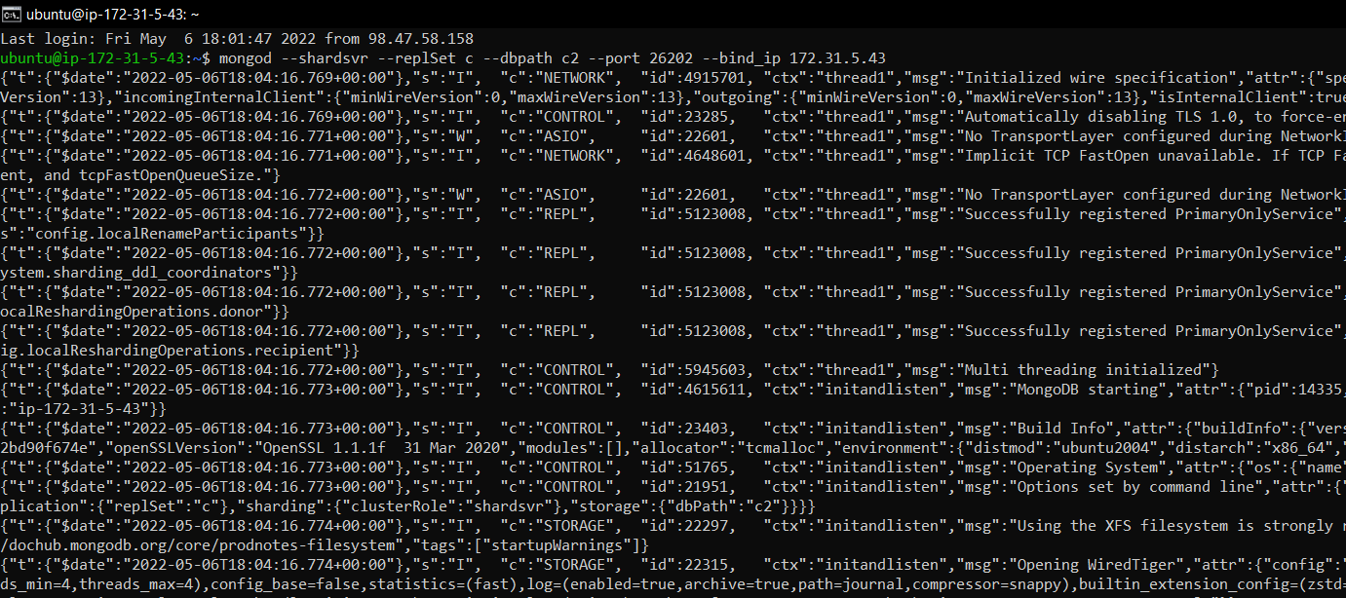

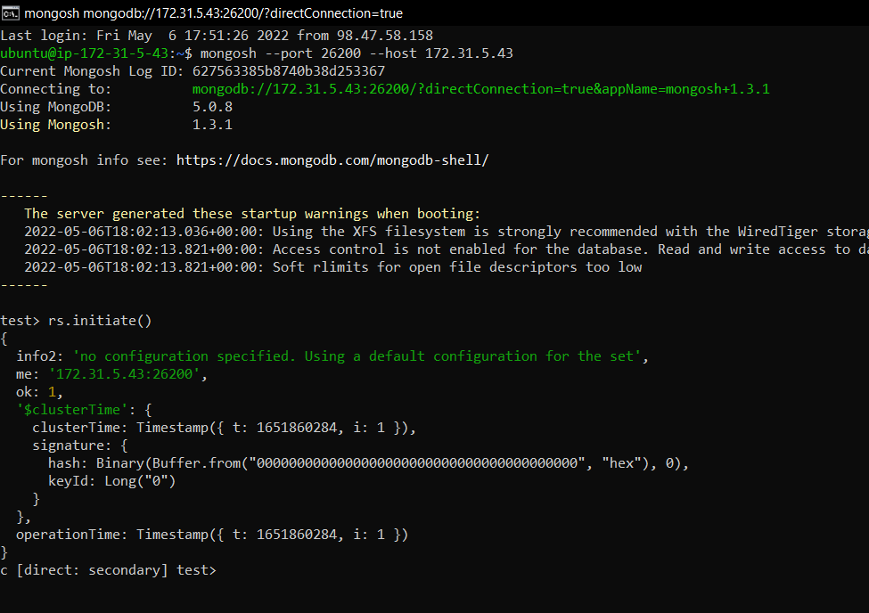

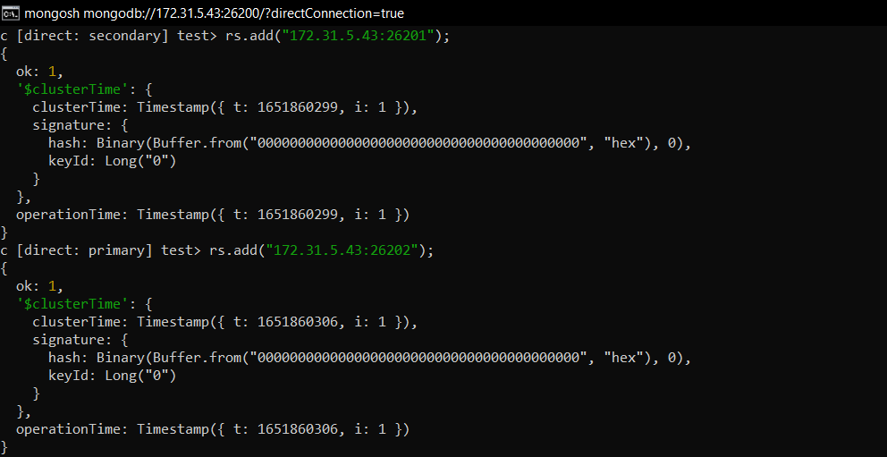

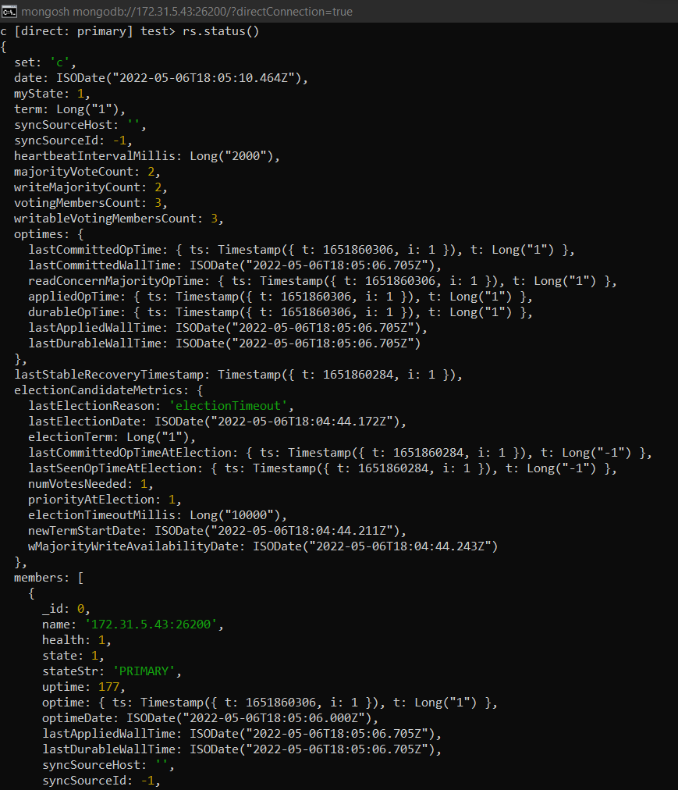

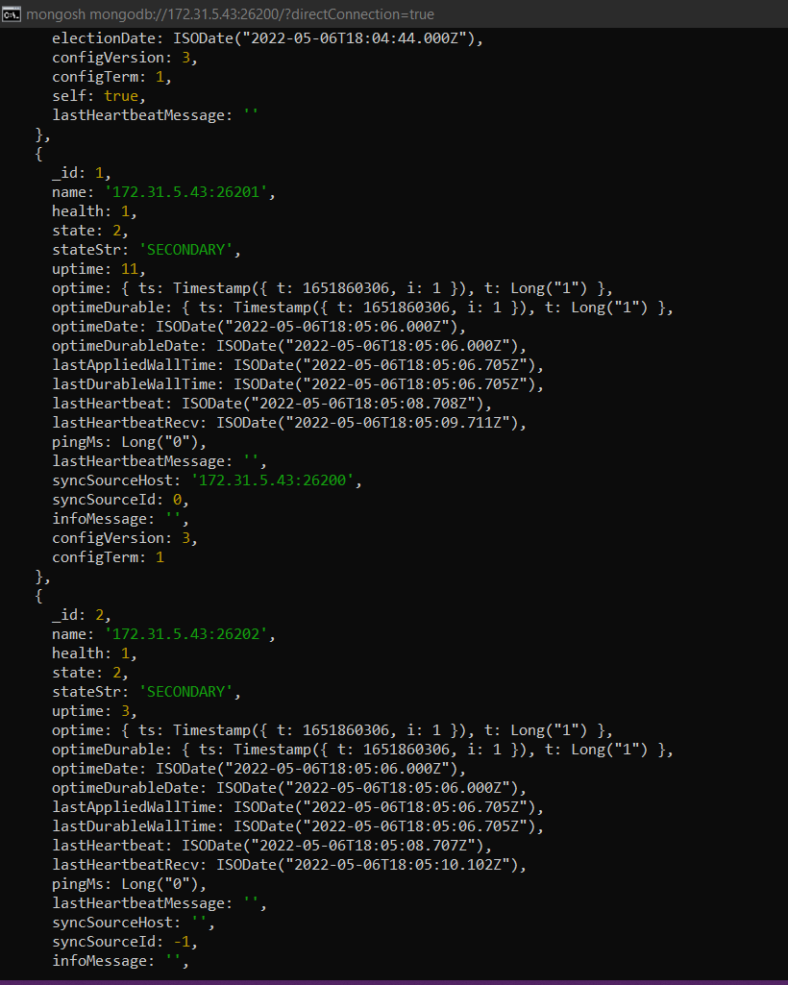

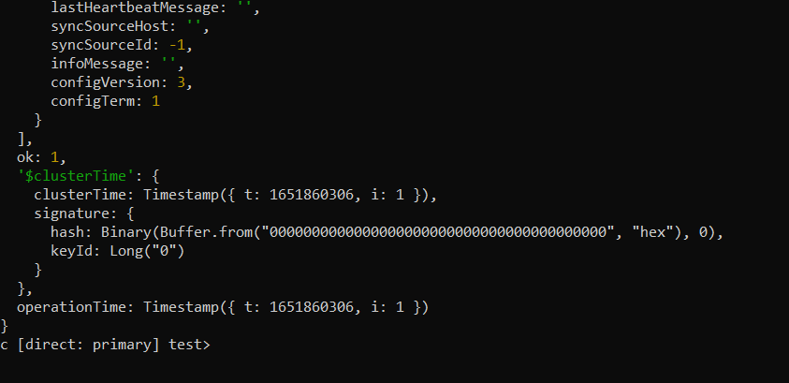

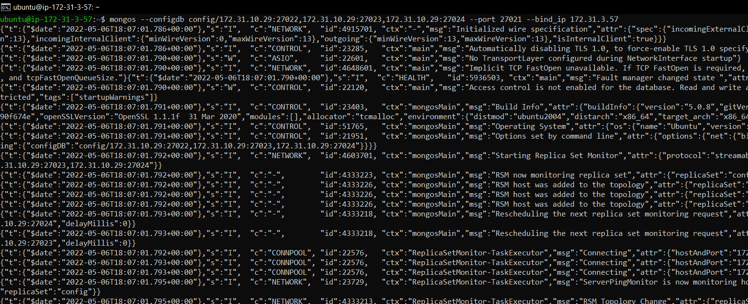

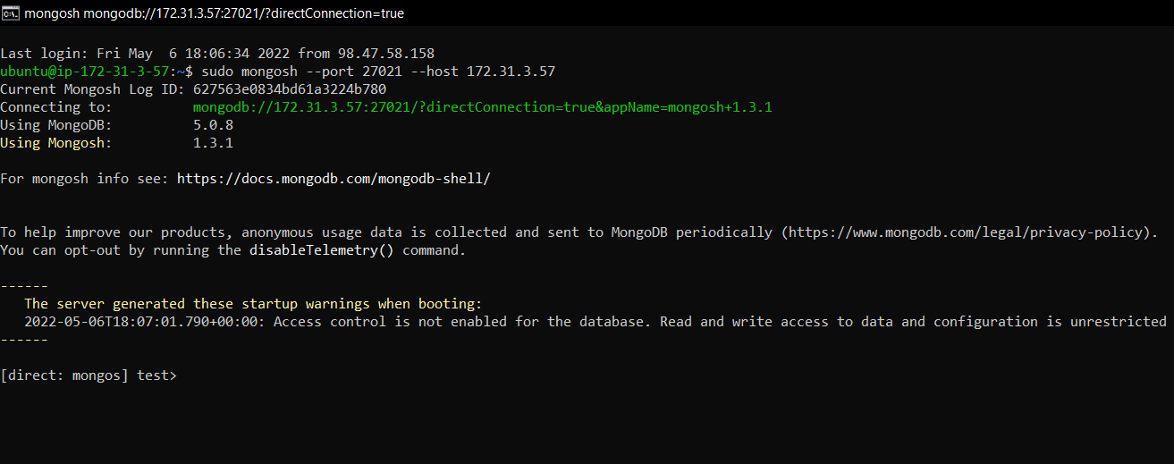

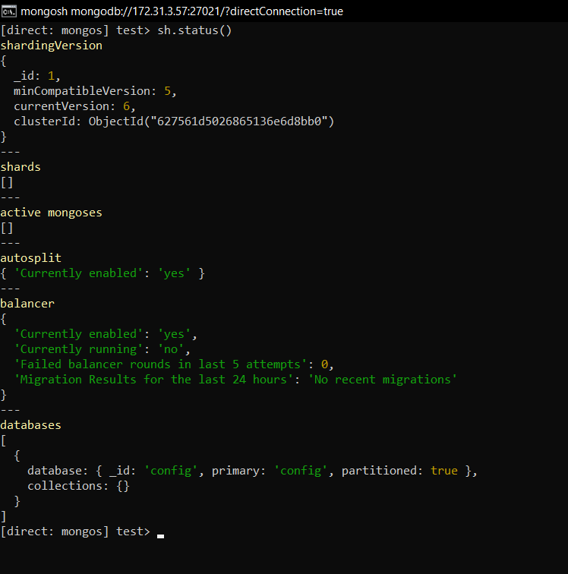

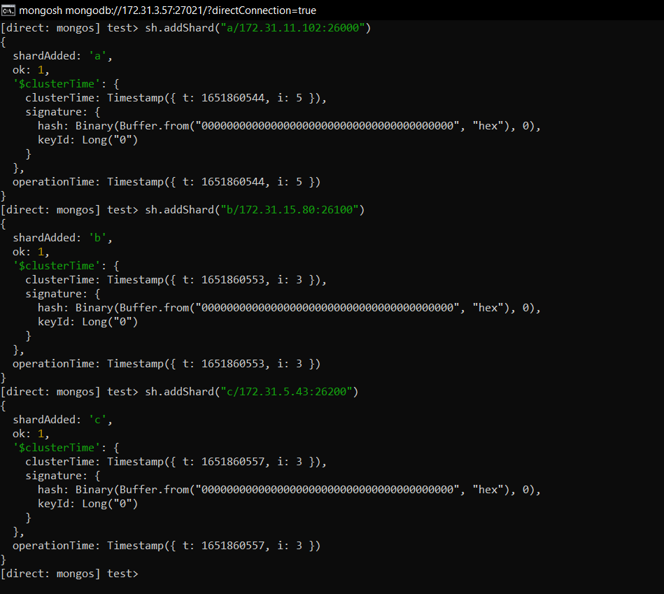

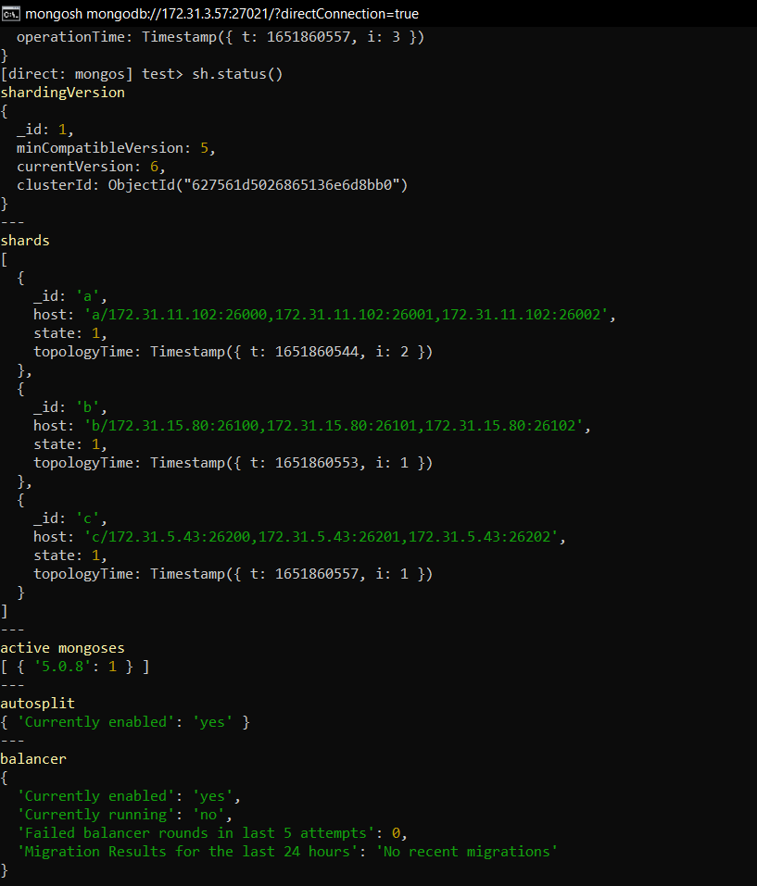

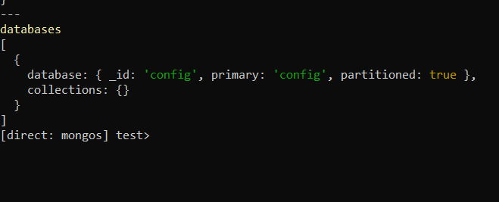

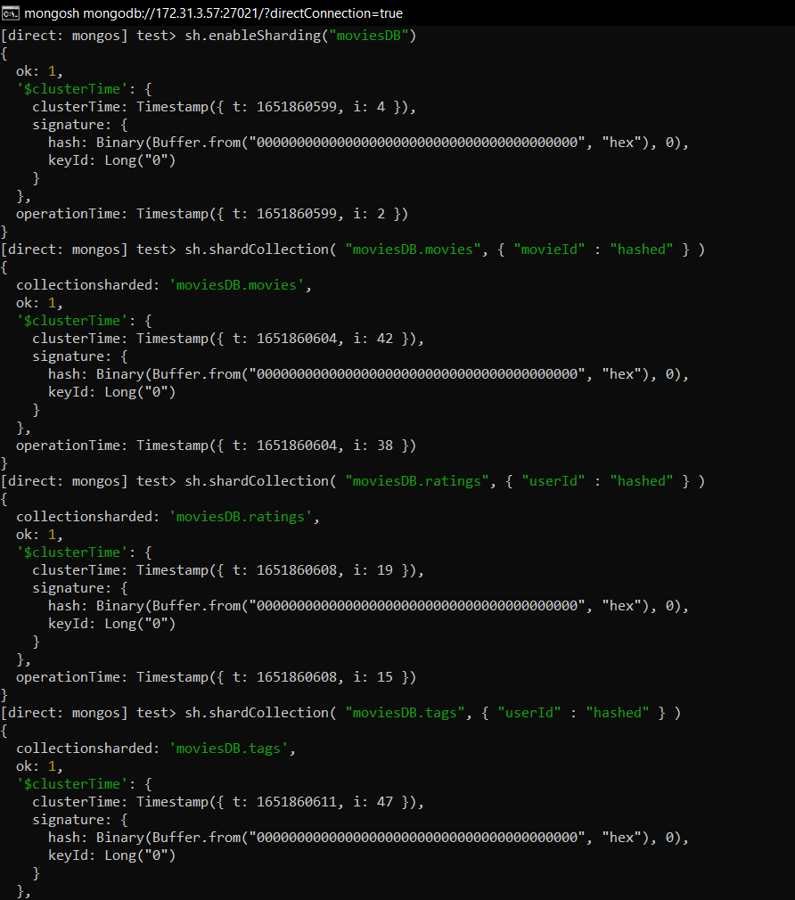

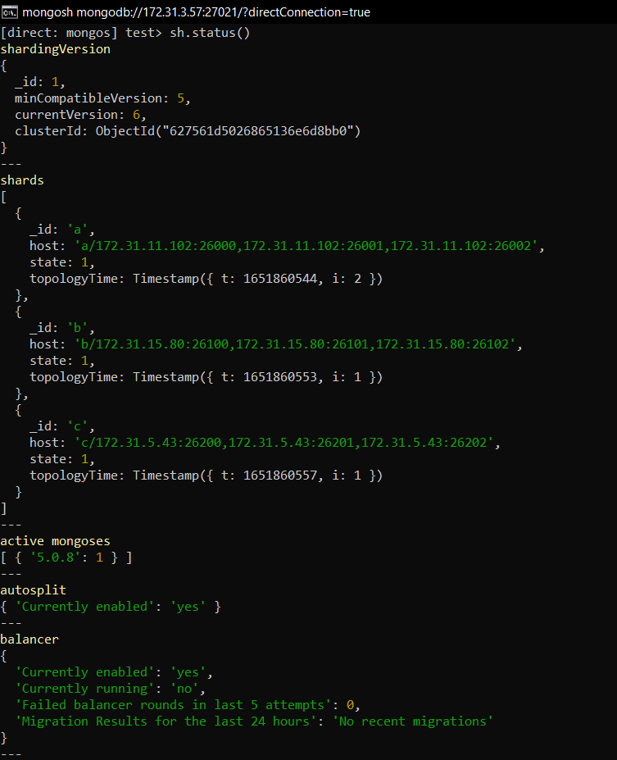

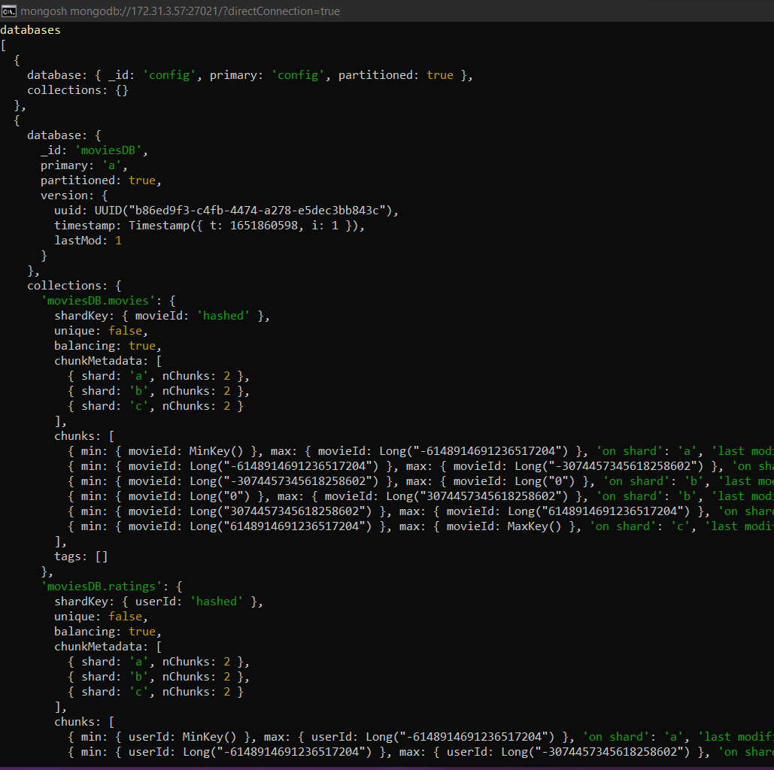

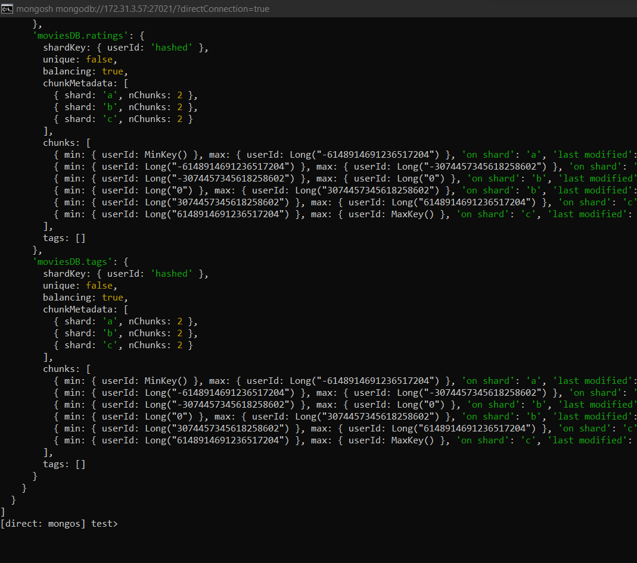

Data Import:

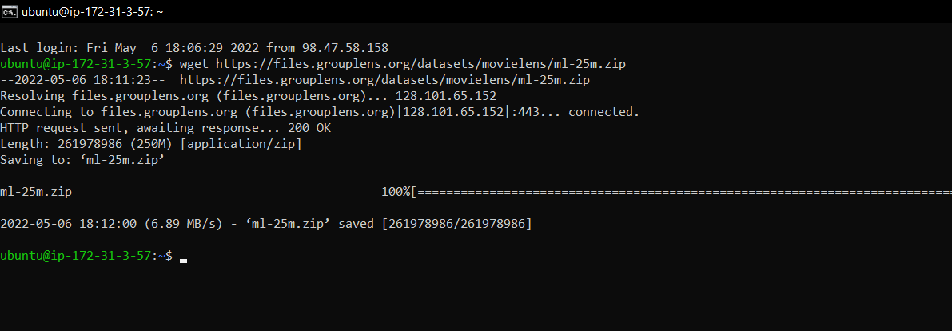

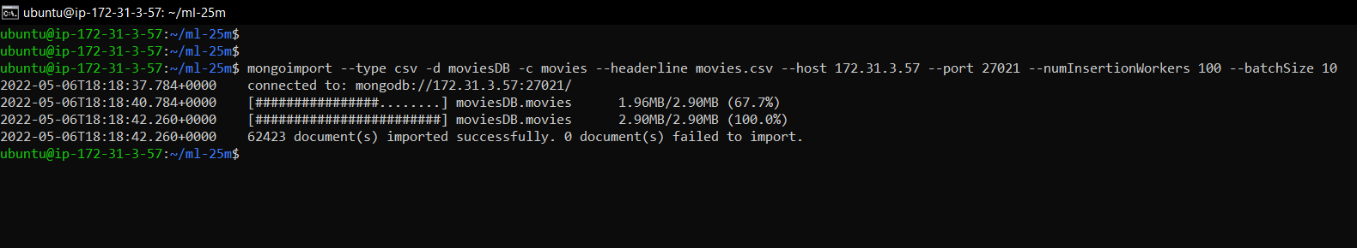

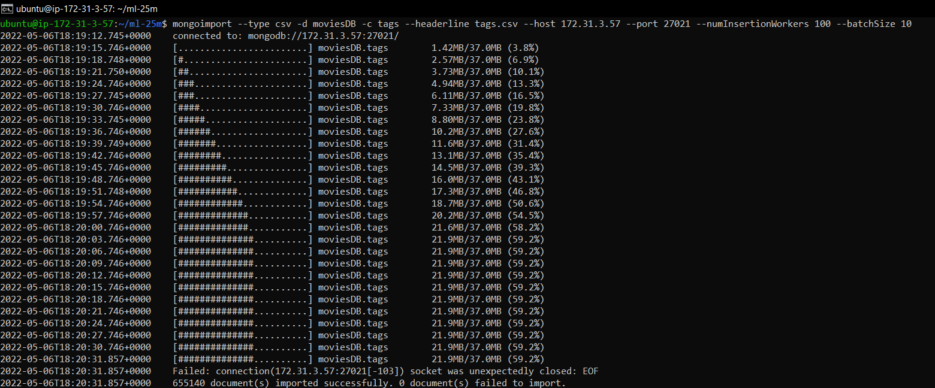

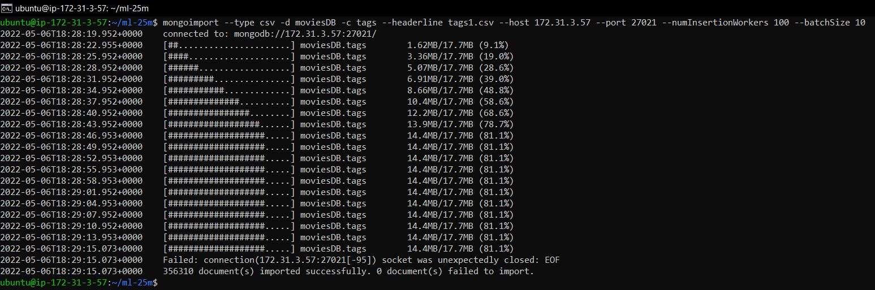

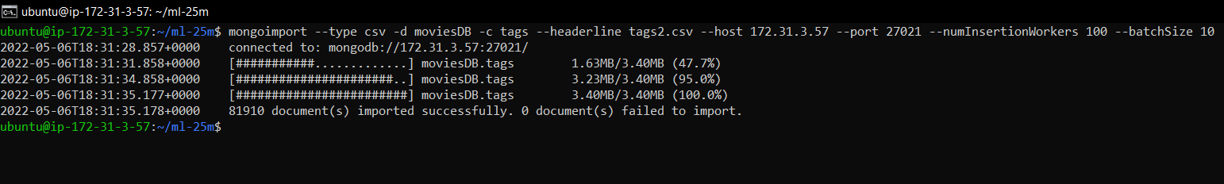

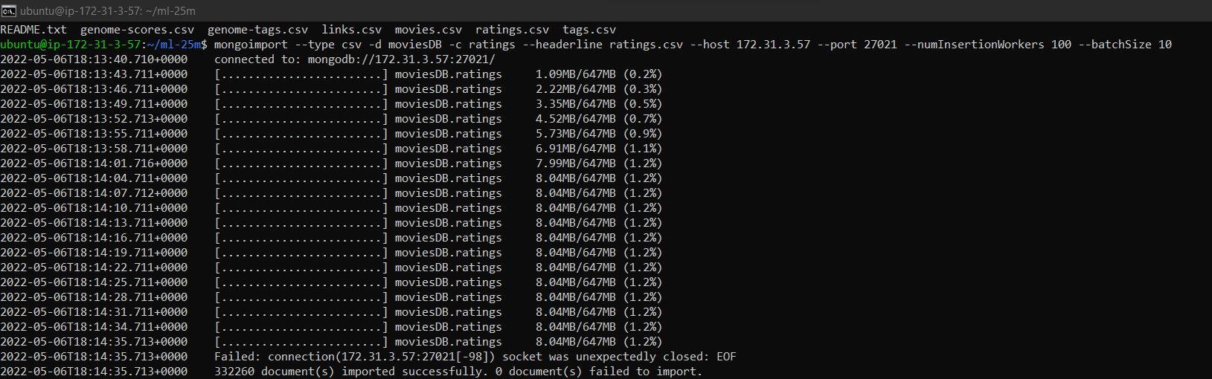

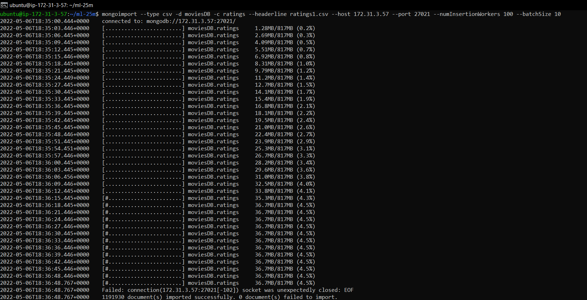

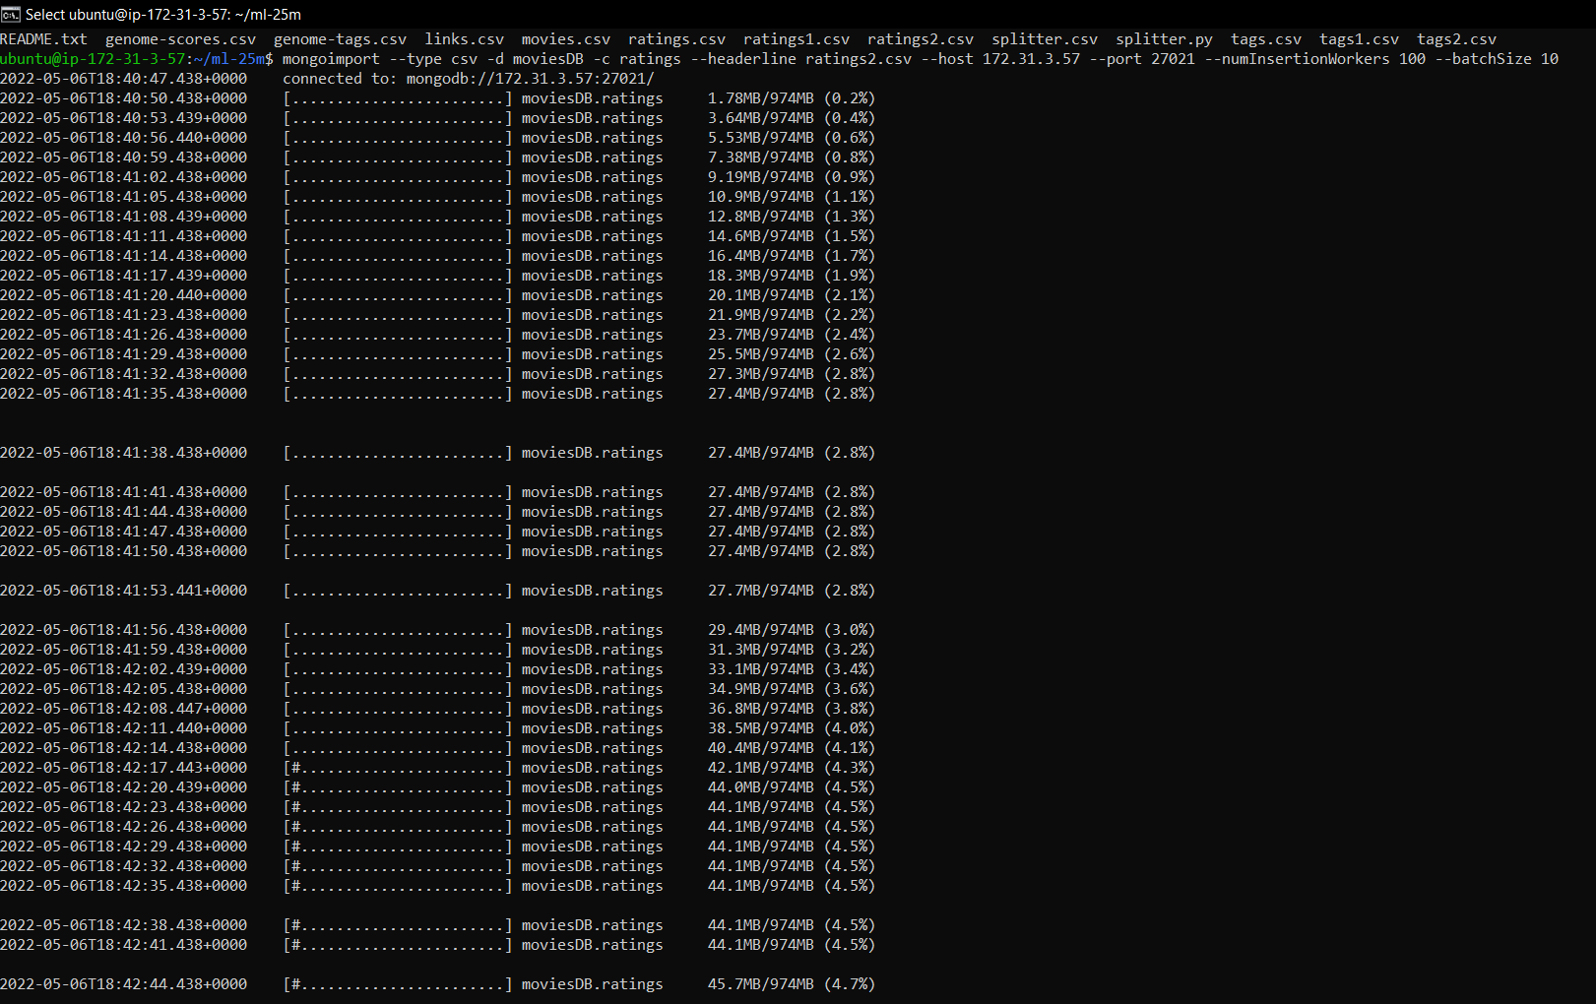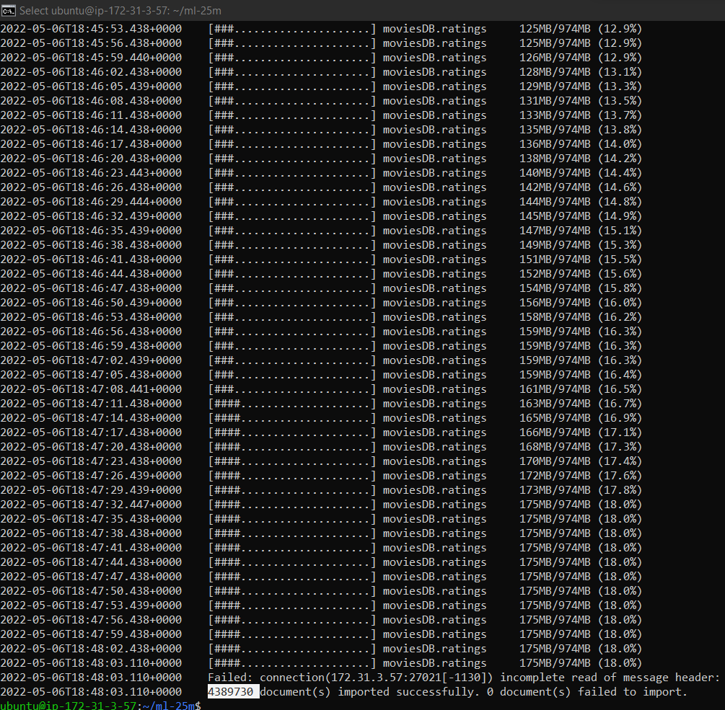

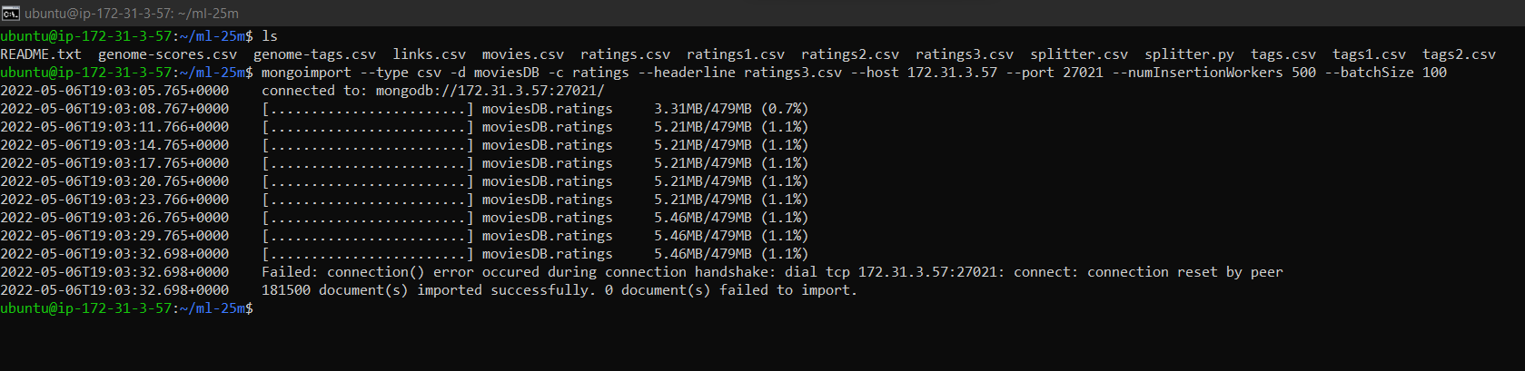

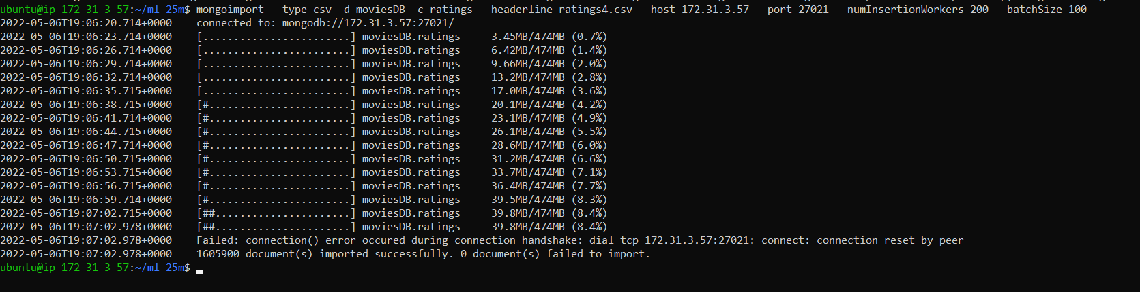

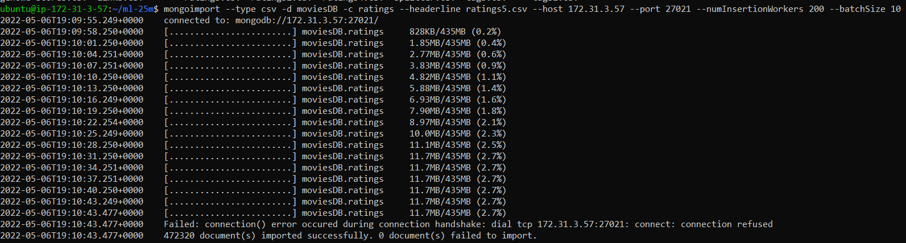

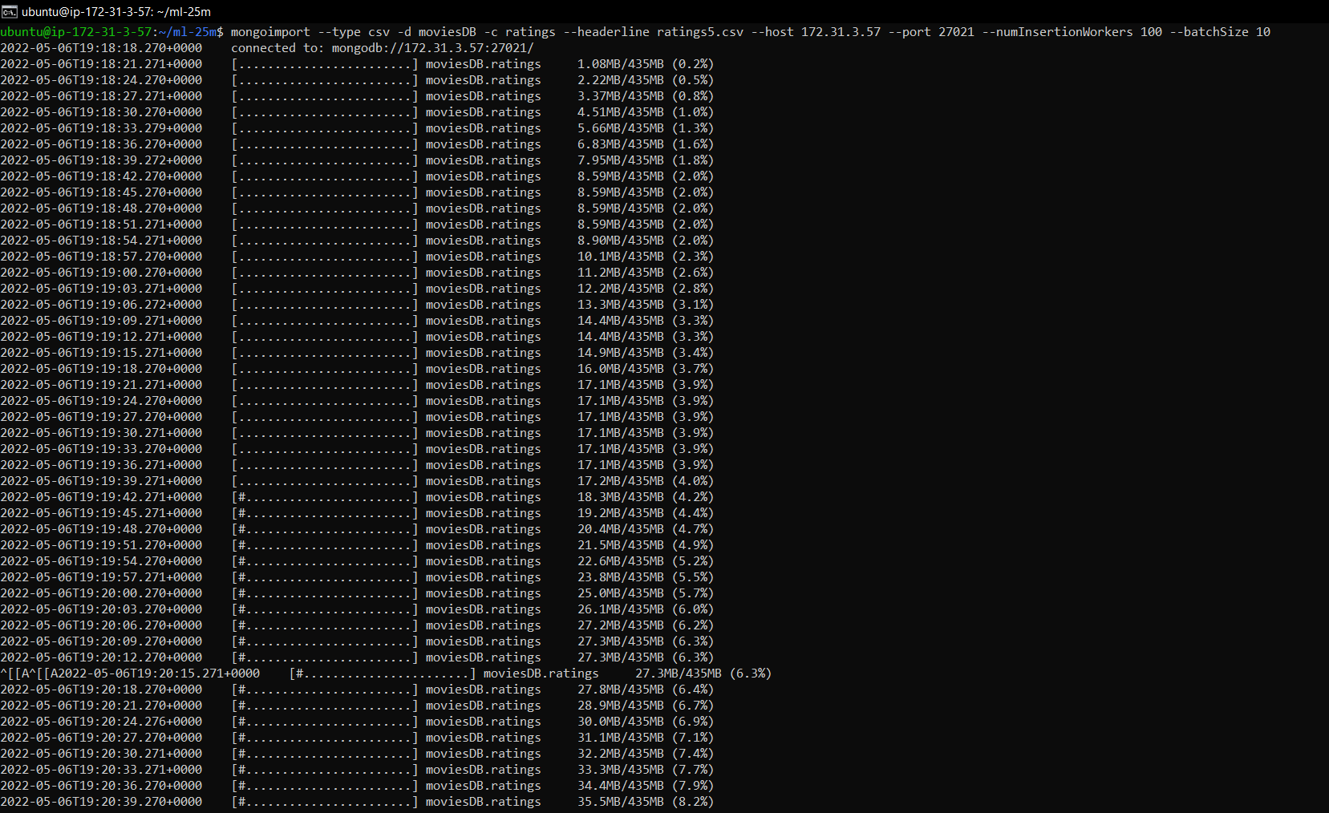

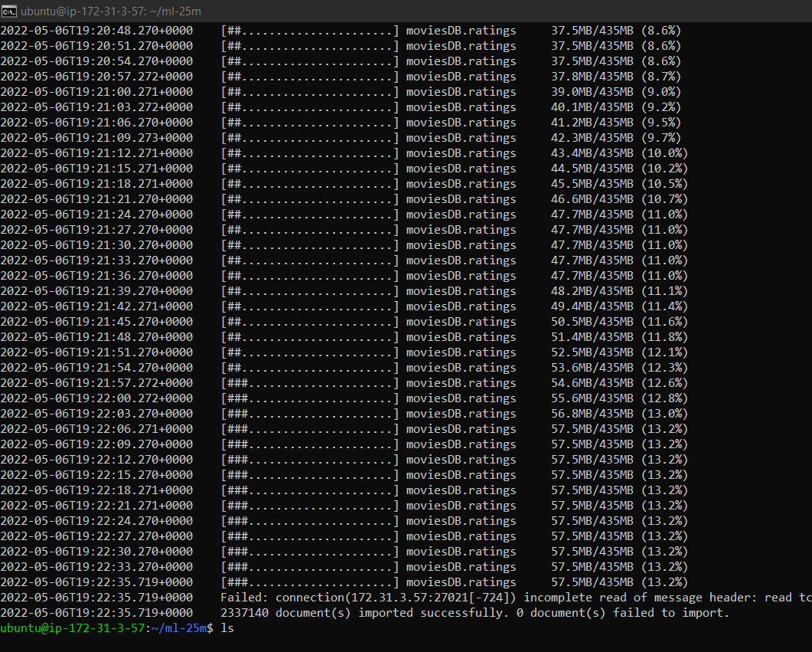

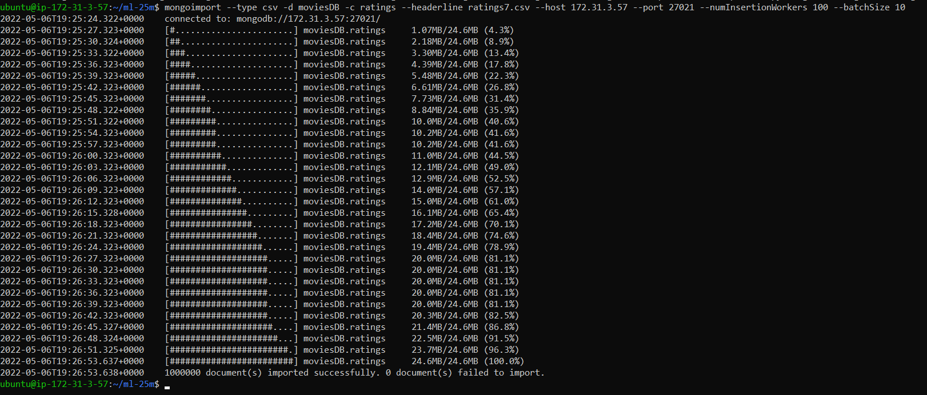

### Explain the rationale behind your shard key and sharding strategy selection.

* + Collection’s name: Movies
    - ShardKey: movieId
    - Strategy: Hashed
    - Explanation: We have high cardinality for the movieId; therefore, we used hashed strategy instead of the range so that documents will be balanced among three shards.
  + Collection’s name: Tags
    - ShardKey: userId
    - Strategy: Hashed
    - Explanation: UserId is unique in the collection that is why we used hashed sharding strategy to increase the scalability of the system
  + Collection’s name: Ratings
    - ShardKey: userId
    - Strategy: Hashed
    - Explanation: To reduce the hotspot problem, we used the hashed strategy. Since userId has high cardinality, hashed strategy improves the performance.

### Brief description on the NoSQL driver of your choice and detailed end-to-end description from your application to the database. You may describe how to make a connection from the application to the data base, how an application submits a command to the database and how it receives a result from the database for this.

* + NoSQL driver: PyMongo
  + To make a connection, we needed to input the database’s uri. This was composed of the instance’s public ip and its associated port number.

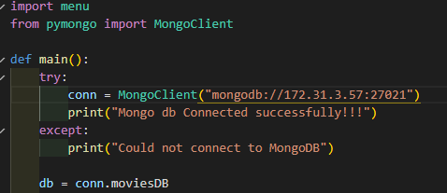

* + Submitting a command to the database requires the collection name and a query.
  + Results are returned as cursors which can then be printed by iterating through them.

### For each 15 functions, include the following items

* + One line of description for that function
  + DDL and/or DML commands of your NoSQL choice to fulfill the function
  + Screenshot(s) to CLEARLY show the function works.

Console Application:

The console application has 5 python code files, the main code being the console.py which connects to the database.Menu.py is for displaying the menu.

Movie.py, tag.py and rating.py are the three individual python codes that have functions that perform the operations on their respective collections.

Menu.py has the list of the functions that we have designed, that are provided on the screen for the users to selecy

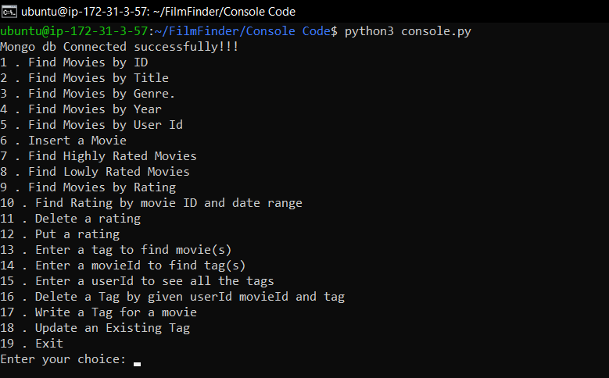

Whenever the user selects an option by enters the number, we read it and then subsequent functions’ inputs are prompted to the user to enter. After all the required inputs are taken the code executes them and shows the results on the screen and then the menu is displayed again. If the user wants to exit the program he/she has to select option 19.

**Functions from the Tag collection which has four fields userId, movieId, tag, and timestamp:**

### Find movie by movie ID

Query command:

db.movies.find({movieId: 223});

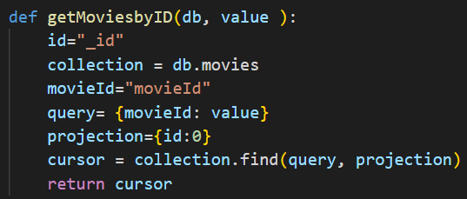

Screenshot:

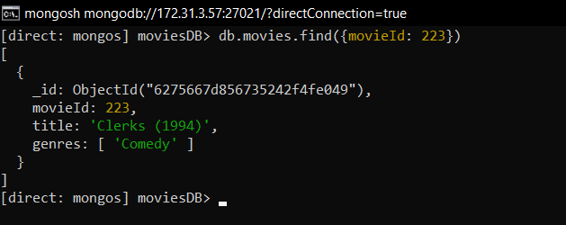

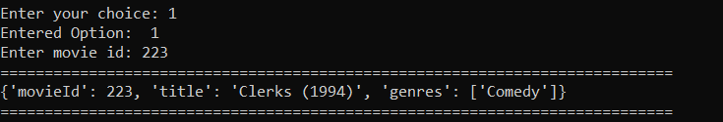

### Find movie given title

Query command:

db.movies.find({title: /Spider/},{_id:0}).limit(5)

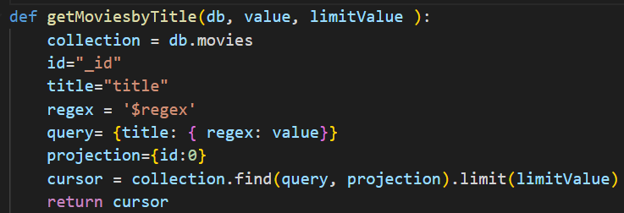

Screenshots:

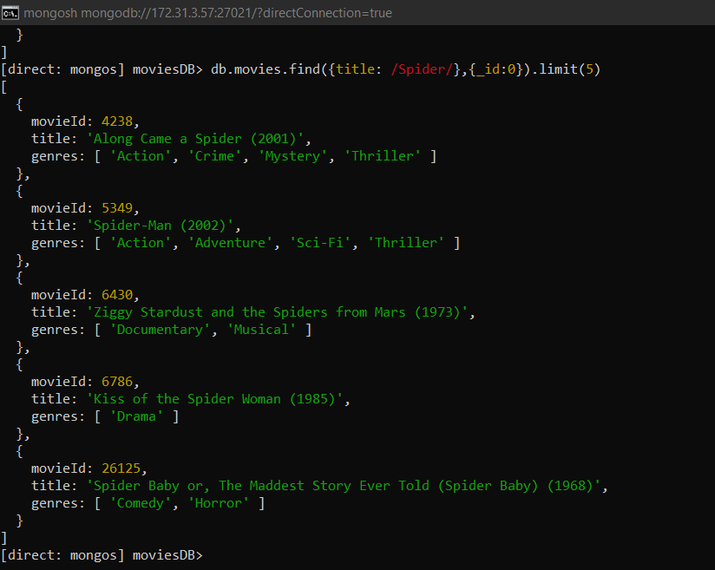

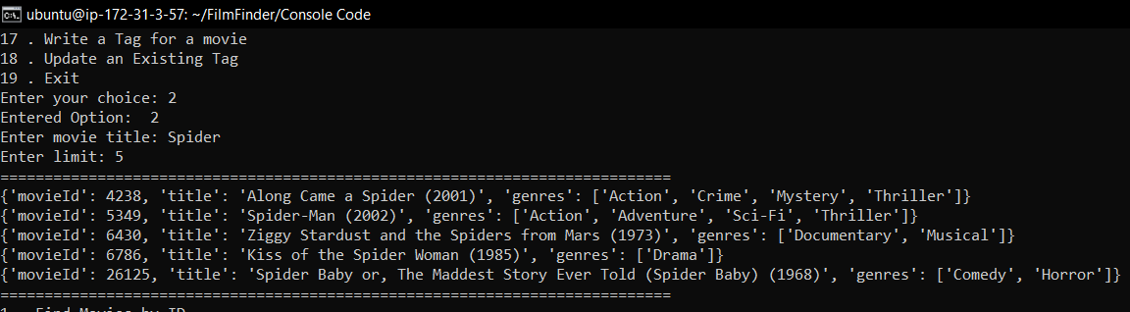

### Find movies given its genre

Query command:

db.movies.find({genres: "Comedy"},{_id:0}).limit(5)

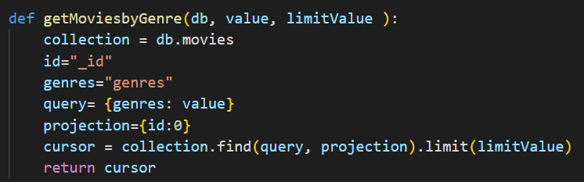

Screenshots:

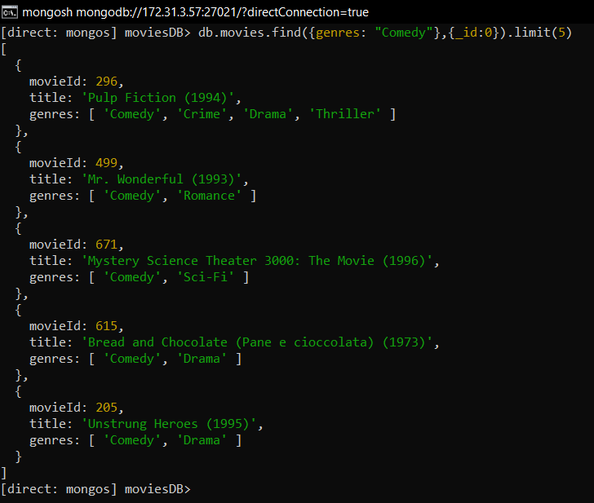

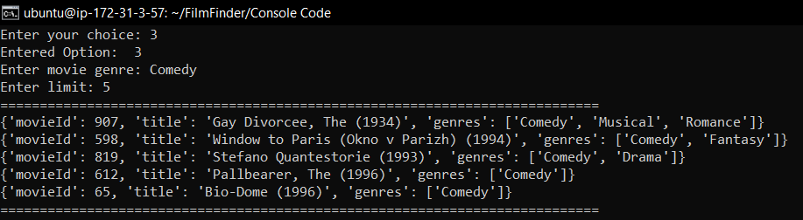

1. Find movies given its year

Query command:

db.movies.find({title: /1990/},{_id:0}).limit(5)

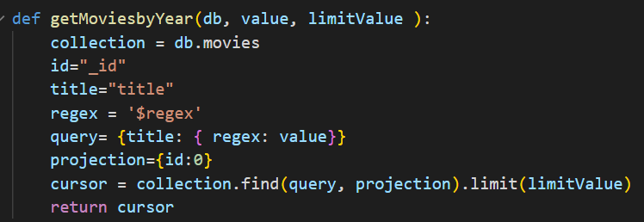

Screenshots:

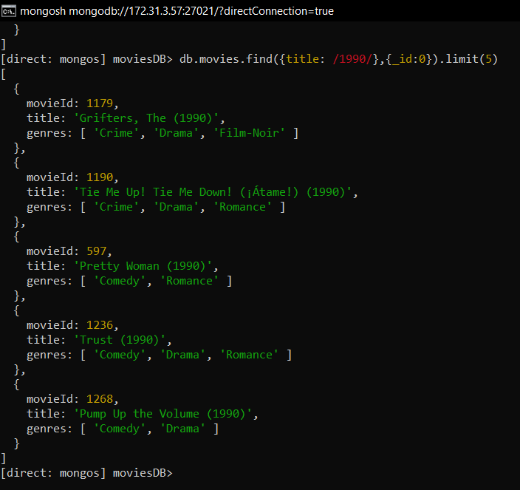

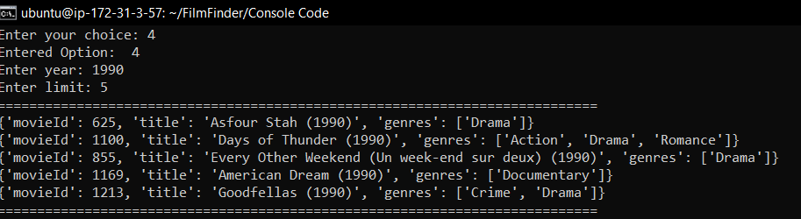

1. Find movie given its user id

Query command:

db.ratings.find({userId : 5},{_id: 0,movieId:1}).limit(5)

db.movies.find({movieId : {$in: [104,113,95,147,150]}},{ _id: 0,title:1})

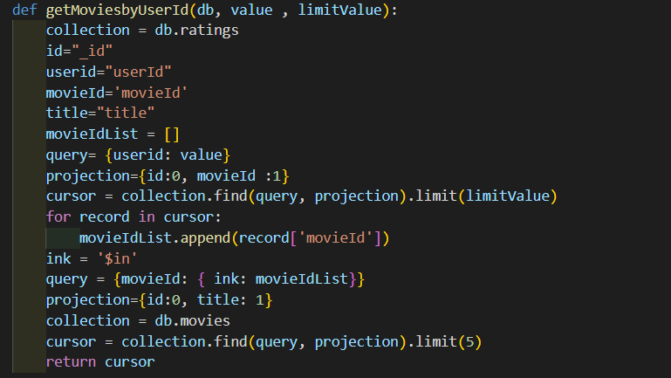

Screenshots:

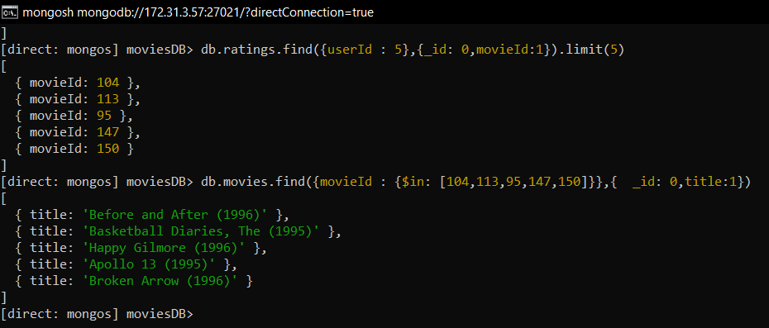

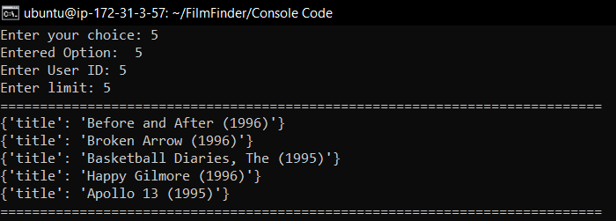

1. Add movie

Query command:

db.movies.find({},{_id: 0, movieId : 1}).limit(1).sort({$natural:-1})

db.movies.insertOne({ movieId : 209080, title : "Ambulance (2022)", genres : ["Action", "Adventure"]})

db.movies.find({movieId : 209080},{_id: 0})

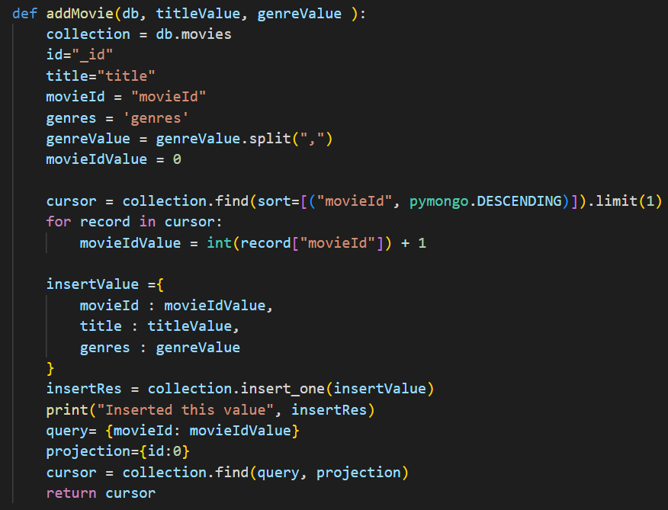

Screenshots:

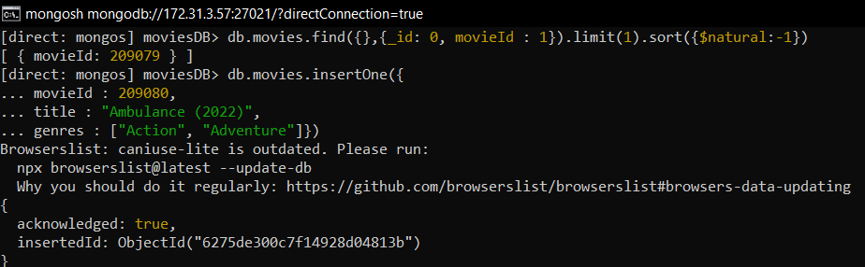

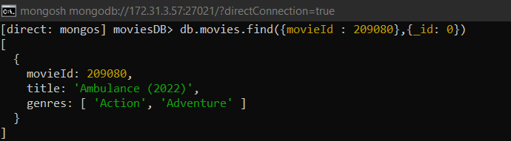

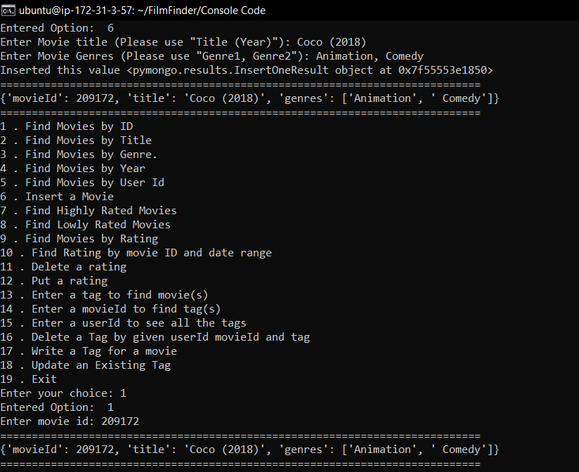

1. Find the highest rated movies

Query command:

db.ratings.find({rating: {$gte:5}},{_id: 0,movieId:1}).limit(5)

db.movies.find({movieId : {$in: [268,527,608,318,1196]}},{ _id: 0,title:1})

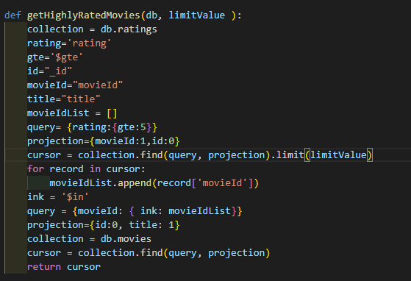

Screenshots:

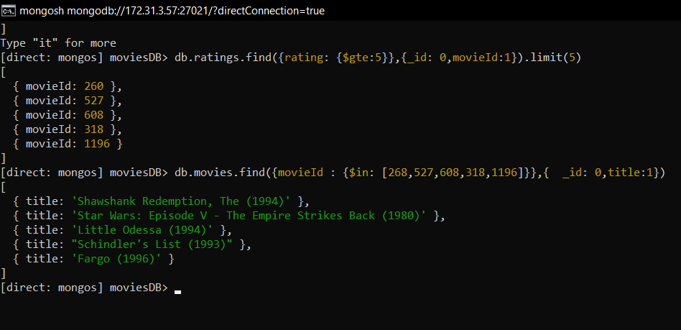

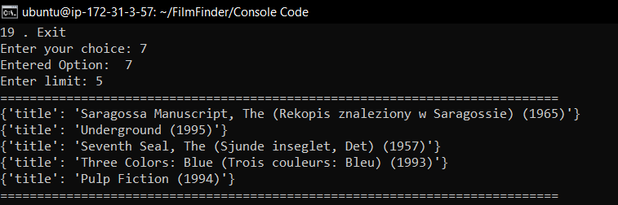

1. Find the lowest rated movies

Query command:

db.ratings.find({rating: {$lte:0.5}},{_id: 0,movieId:1}).limit(5)

db.movies.find({movieId : {$in: [5269,60,1562,33158,33495]}},{ _id: 0,title:1})

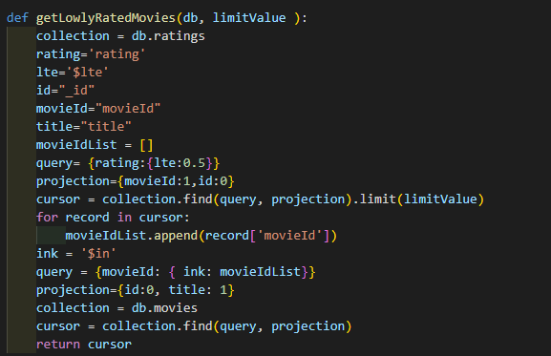

Screenshots:

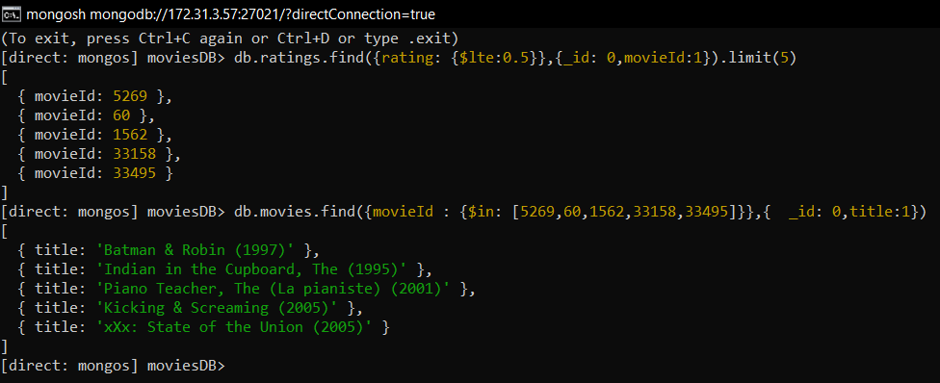

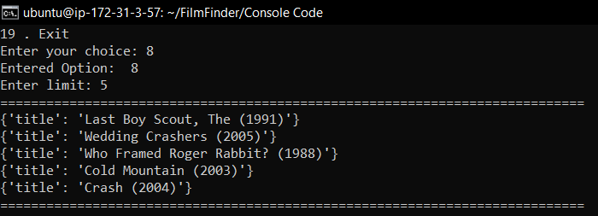

1. Find the movie given the Rating

Query command:

db.ratings.find({rating: 2.5},{_id: 0,movieId:1}).limit(5)

db.movies.find({movieId : {$in: [1042,344,154,415,532]}},{ _id: 0,title:1})

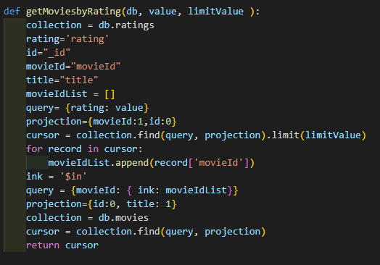

Screenshots:

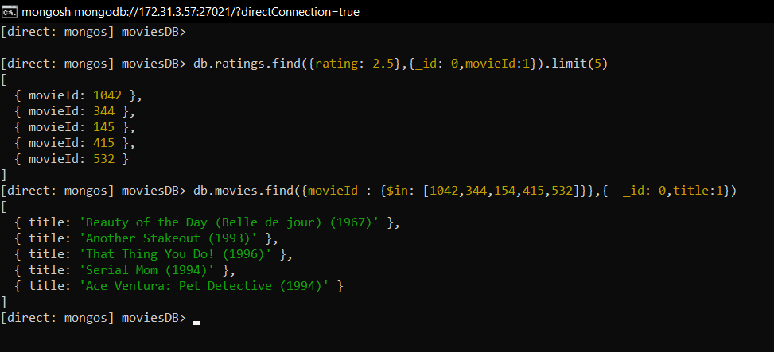

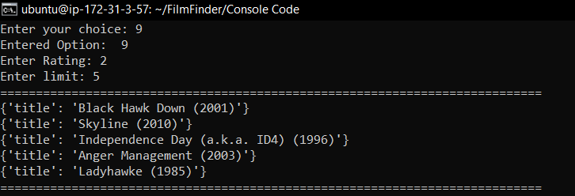

1. Find ratings given movie and timestamp range

Query command:

db.ratings.find({movieId: 307, timestamp: {$gte: 832059248, $lte:1256677221}}, { _id: 0, userId:1, movieId: 1, rating: 1, timestamp: 1}).limit(5)

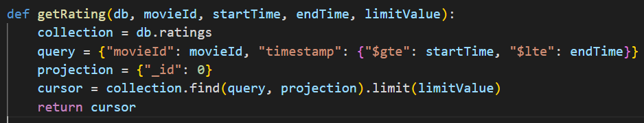

Screenshots:

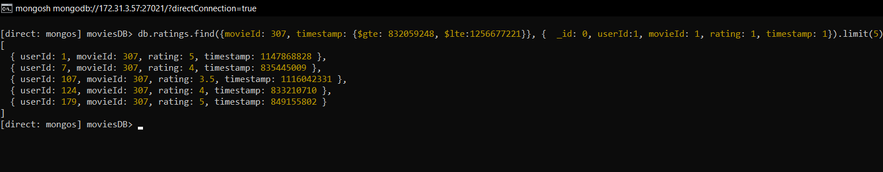

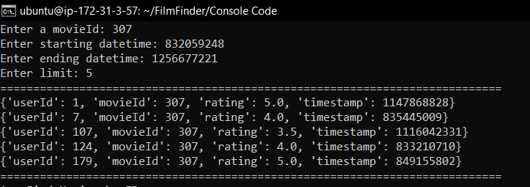

1. Admin delete rating

Description: This function deletes a rating from the database given its movie id and user id.

Query command:

db.ratings.find({userId: 1, movieId: 4703})

db.ratings.deleteOne({userId: 1, movieId: 4703})

db.ratings.find({userId: 1, movieId: 4703})

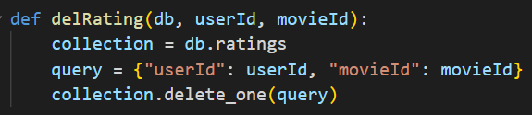

Screenshots:

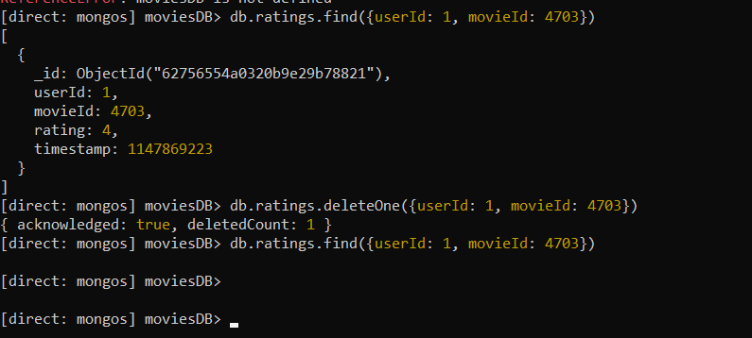

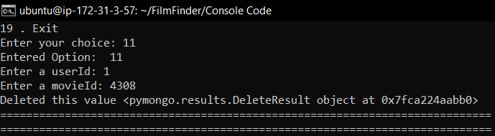

1. User adds in their own rating on a movie

Description: A user can put a rating to the database given user id, movie id, rating, and timestamp. If the user id and movie id pair already exists, then it will instead update its value.

Query command:

db.ratings.insertOne({userId: 1, movieId: 2, rating: 4, timestamp: 12345})

db.ratings.find({userId: 1, movieId: 2})

db.ratings.updateOne({{userId: 1, movieId: 2}, {$set: {rating: 1, timestamp: 12349}})

db.ratings.find({userId: 1, movieId: 2})

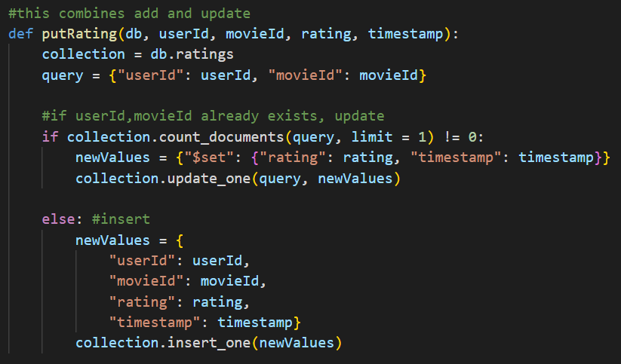

Screenshots:

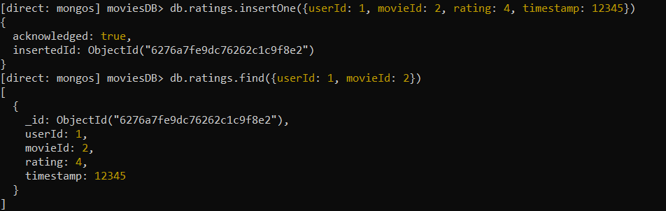

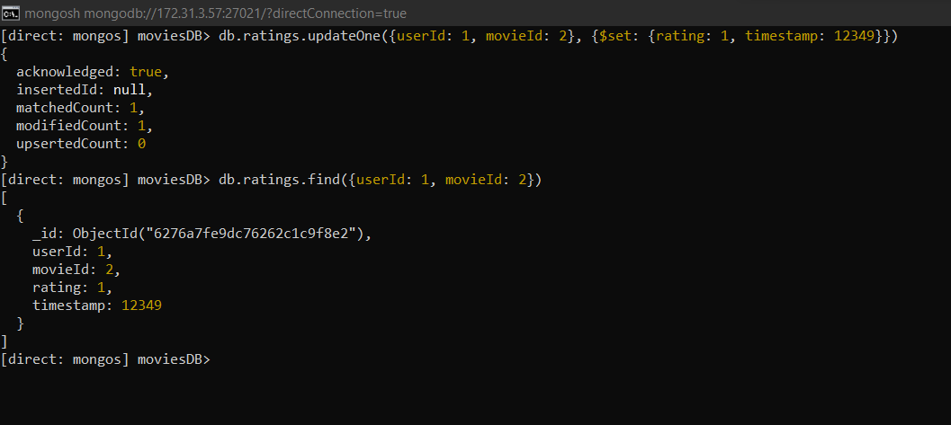

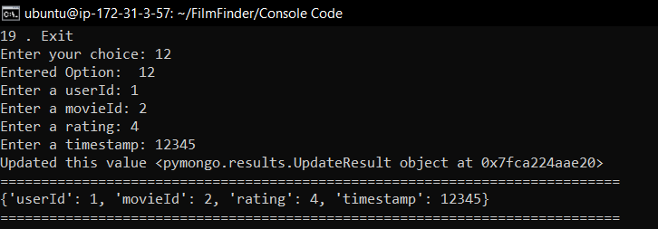

### Find movies by a given tag

Query command: db.tags.find({tag:"history"},{_id:0}).limit(10)

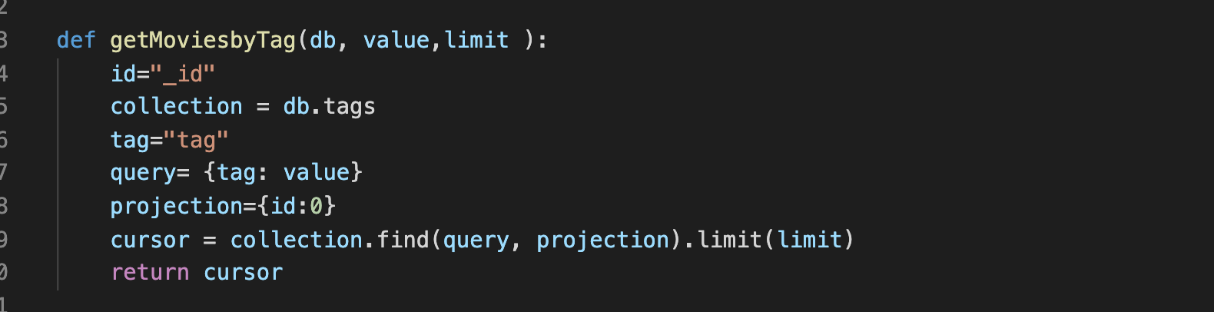

Screenshot:

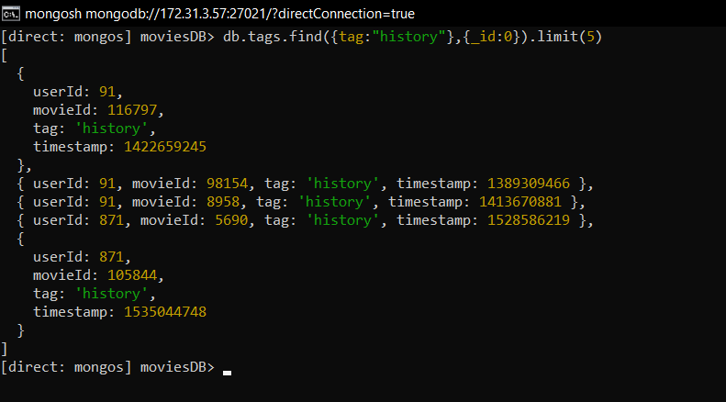

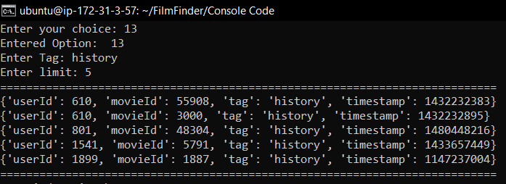

### Find tags given movie

Query command: db.tags.find({movieId:1234},{movieId:1,tag:1,_id:0}).limit(10)

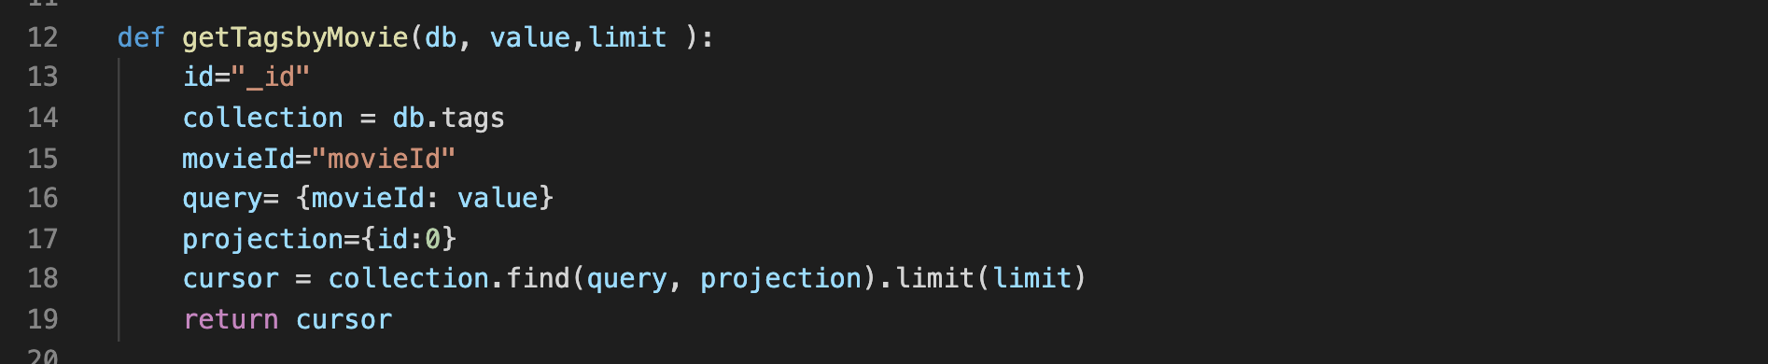

Screenshots:

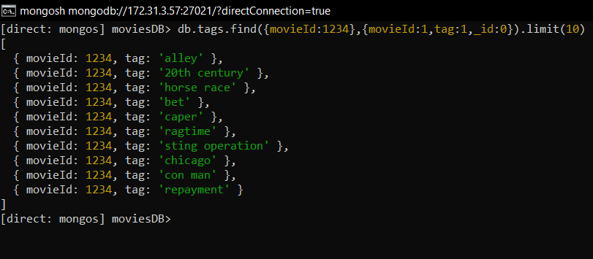

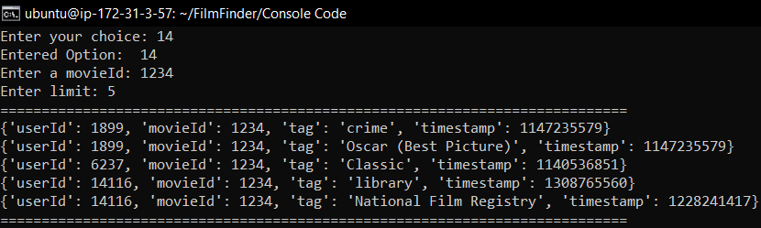

1. Find tag given userID

Query command: db.tags.find({userId:73406},{_id: 0})

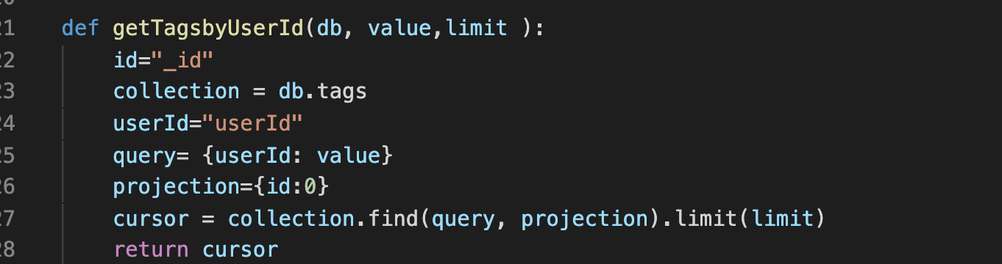

Screenshots:

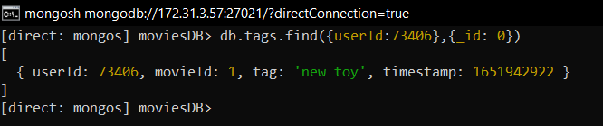

### 

### User deletes tags

Query command: db.tags.deleteOne({userId:73406,movieId:1,tag:”new toy”})

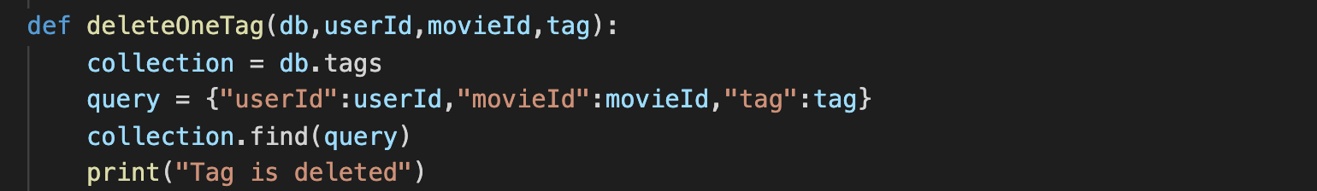

Screenshots:

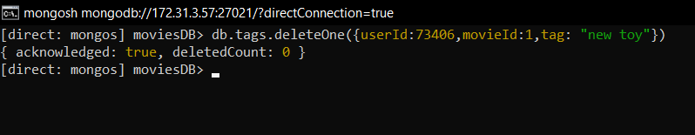

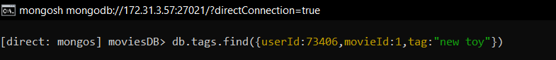

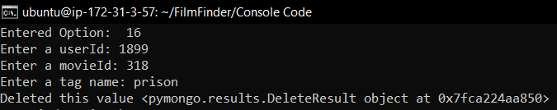

1. A user adds tags on a movie

Query command: db.tags.insertOne({userId:73406,movieId:1,tag:”fantastic”,timestamp:1651942922})

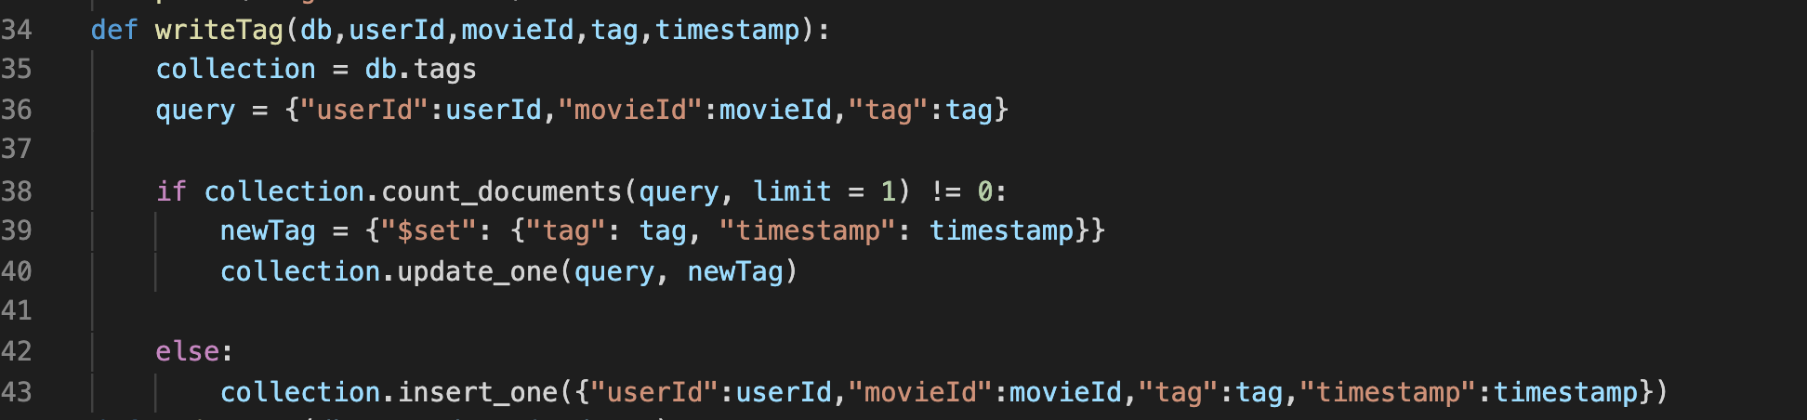

Screenshots:

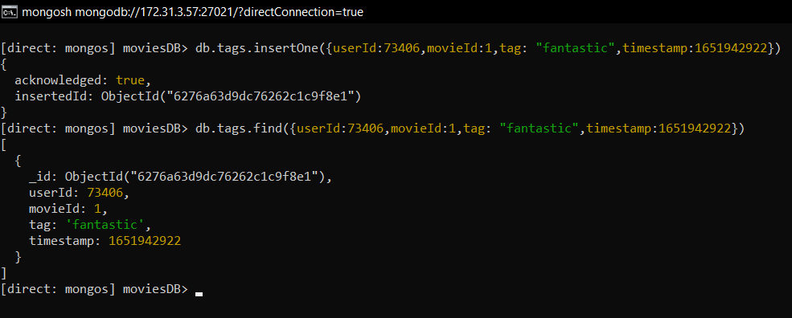

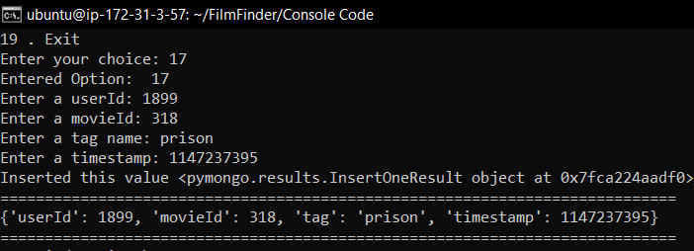

1. User update tags on a movie

Query command: db.tags.updateOne({userId:73406,movieId:1,tag:”fantastic”},{$set:{tag:”new toy”}})

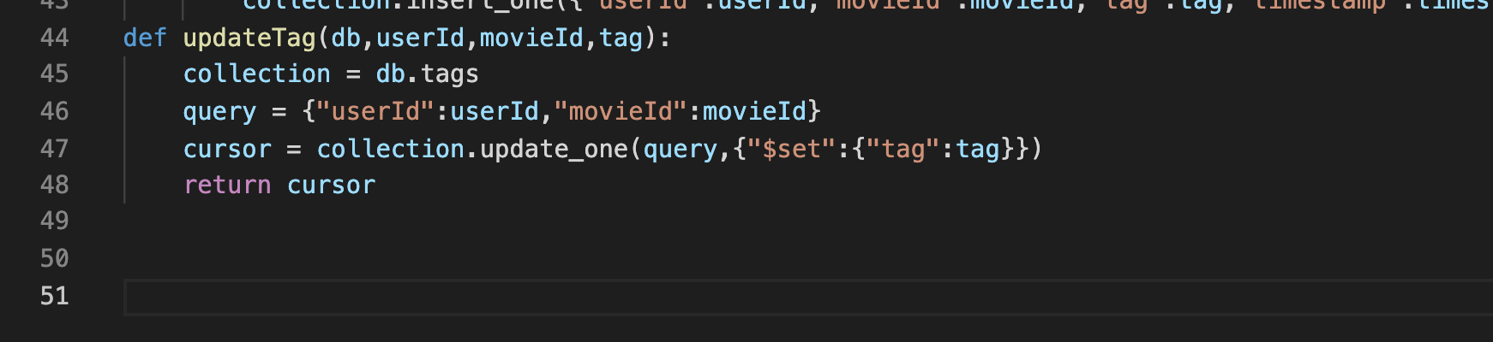

Screenshots:

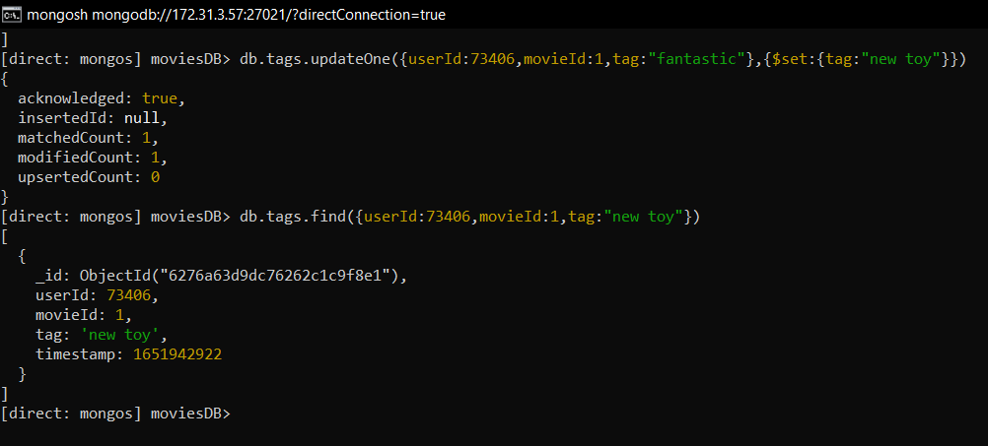

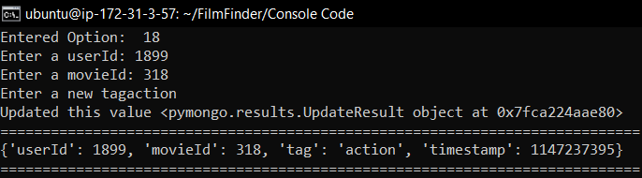

1. Exit

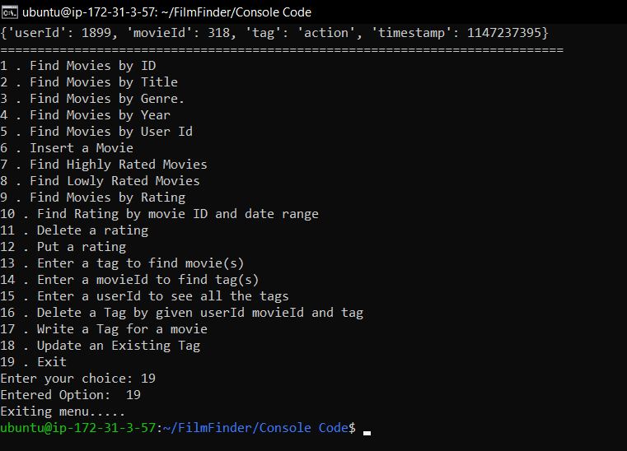

API code



